2017-18

HASI
Homeland Association for Social Improvement
Oskhali , P.O. & P.S. Hatiya,
Noakhali, Bangladesh
Annual Report

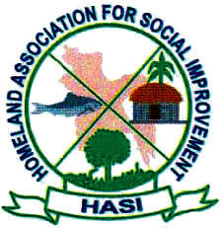

PREFACE

Homeland Association for Social Improvement (HASI) started its journey to the development path from May 25, 1996 and crossed Twenty Two years of its development march by 30th June 2018 successfully. Though there were lot of limitations and problems during last Twenty Two years, the activities have not been stopped but continued its development efforts with own speed, where there were successes and failures also. In the mean time, new thoughts and ideas have been introduced in our development interventions and created new innovate sustainable ideas. The demand and expectations of the people have changed with the march of creative world leaving previous thoughts and expectations, which result innovation and addition of new development techniques.

We have been working hard unitarily to make the people into human resources and to spread their inner heart fully through increasing their fullest participation in development process. Empowerment of the poor and participation of the women side by side of their male partners are the precondition of our development, we are paying our heartiest regards to the respected Executive Committee Members and General Council Members, whose' valuable advice and efforts encouraged and initiated us. Remembering the field staff, those have performed the difficult responsibilities at the grass roots levels for making the programs effective and successful and paying cordial wishes and regards. We are grateful to the Donors, advisors and the government administrations, different departments and the sister organizations for their cordial cooperation and supports for the implementation of the organizational activities.

Advocate Akram Hossain

Executive Director

Homeland Association for Social Improvement (HASI)

Oskhali , P.O. & P.S. Hatiya,

Noakhali, Bangladesh.

Basic Information

Name of the organization : Homeland Association for Social Improvement (HASI)
Date of Establishment : 25th May 1996
Registration Number : a) Homeland Association for Social Improvement
(HASI) is registered as a Non-Govt. Organization
(NGO with the Social Welfare Department, Govt. of Bangladesh, Reg. No. NOA-478.
- Homeland Association for Social Improvement
(HASI) is registered with NGO Affairs Bureau, Government of Bangladesh under Foreign Donations (Voluntary Activities) Regulation Rules, 1978. Reg. No. 1499.
Office Timetable : Saturday to Thursday
9.00 am to 5.00 pm
Holiday : Friday
Geographical Location :
Sl. | Division | District | Upazilla | No. of Unions | No. of Village
1. | Chittagong | Noakhali | Hatiya | 11 | 82
2. | Chittagong | Noakhali | Suborno Char | 4 | 12
3. | Chittagong | Chadpur | Hajjigong | 4 | 30
4. | Chittagong | Ranghamati | Khawkhali | 6 | 40
5. | Dhaka | Kishorgong | Bhairab | 3 | 28
6. | Chittagong | Noakhali | Kabirhat | 7 | 20
 | Total |  |  | 35 | 212

Background:
HASI is a non-profit, non-political non-Government voluntary organization active in health and development sector. For socio-economic uplift and improvement of the quality of life of poor, Landless, vulnerable, destitute and river erosion people of Hatiya (an island) under Noakhali District some young energetic local people established the organization in 1996. The organization since its inception has been working for building institutions of the poor with special emphasis on distressed women, girls and disabled people. Main thrust of HASI program is to organize the rural poor men and women into groups in order to enable them to manage and control for themselves, identify their problems and also find out solutions as assertive population.

The socio-economic situation of people of working areas of HASI is very much backward. Such as landless, poverty, unemployment, malnutrition, illiteracy, absence of major population from social decision making process and resource constraints are some major problems in these areas. Besides natural disaster make a regular Visit causing devastated sufferings of the people.

With these socio-Economic realities, HASI started its mission to facilitate the targeted partners toward their sustainable development and social transformation though technology transfer, make free excess and optimum use of local resources.

Vision:

HASI dreams of a society where without any discrimination and division of sex, caste, color, the people will enjoy full dignity and enable themselves to be involved and participate in the mainstream development for sustainability and empowerment.

Mission:
HASI works with people whose lives are dominated by extreme poverty, illiteracy, disease and handicaps. With multifaceted development interventions HASI strives to bring about positive change in the quality of live of the poor people of HASI's working areas.

HASI is committed to making its program socially, financially, and environmentally sustainable, using innovative methods and appropriate technologies. HASI firmly believes and is actively involved in promoting human dignity and gender equity.

Although the emphasis of HASI's work is at the individual level, sustaining the work of the organization depends on an environment that permits the poor to break out of the cycle of poverty and hopelessness, which frustrates them. To this and HASI endeavors to bring about change at the level of national and global policy on poverty reduction an social progress.

The fulfillment of HASI's mission requires the contribution of competent professionals committed to the goals and values of HASI. HASI, therefore, fosters the development of the human potential of the members of the organization and those they serve.

Objectives:

- To eradicate illiteracy imparting children and adult education.
- To develop the socio-economic condition of the target people through organizing them in to small groups, capital formation, motivation and non-formal education.
- To identify the problems and resources of the target people and taking steps / initiatives to solve the problems with their own efforts.
- To make the target people skill, conscious, and qualified through arranging training seminar and workshop.
- To create employment and earning opportunities through undertaking different appropriate, viable, and feasible income generating activities.
- To create favorable health atmosphere and to control population growth through providing primary health and family planning education.
- To develop interest and increase the participation of women in development activities.
- To eradicate social barriers, religious superstition, injustices, exploitation, deprivation etc. through educational and motivation.
- To reduce social diseases like divorce, acid throwing, tender age marriage, and torture through increase the awareness.
- To develop the local environmental situation through tree-plantation and nursery development.
- To dig silted ponds and to cultivate fishing.
- To rehabilitate the disables by nursing and educating so that they can participate in income generating activities.
- To educate the land less farmers on regenerative agricultural development.
- To undertake relief and rehabilitation activities at the time of disaster period to help the victims.

Activities carried out in the project Duration in a brief:

HASI Running Program:
HYSAWA-GOB and DANIDA-SDC April 2014 December 2016

Group Formation:
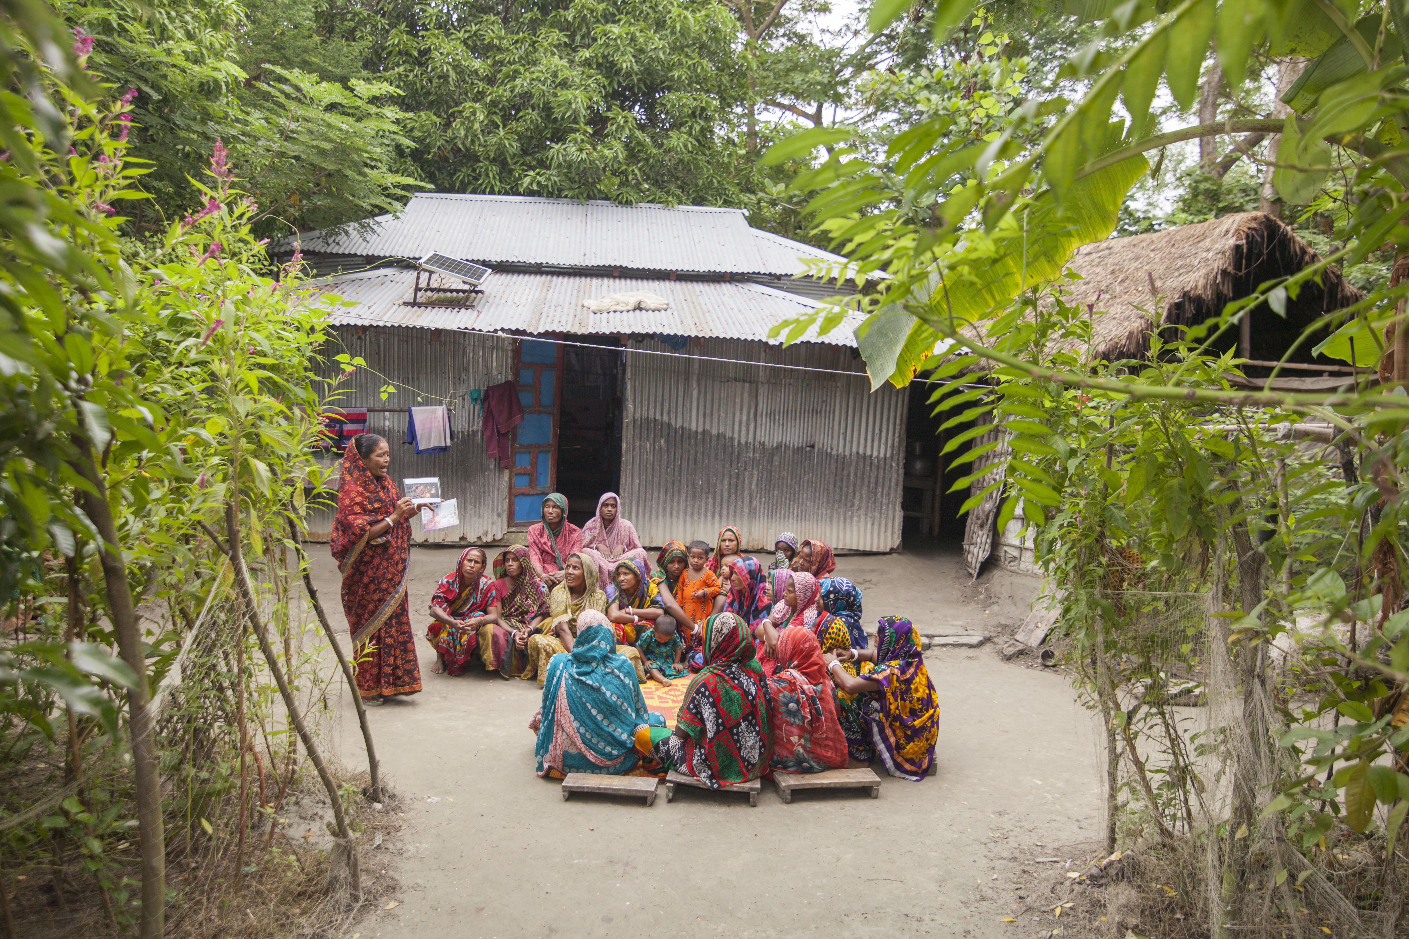
In the project period HASI organized 1200 VDC (Village Development Group). Per group member 25-30. HASI staff regular meeting with group member for their capacity building.

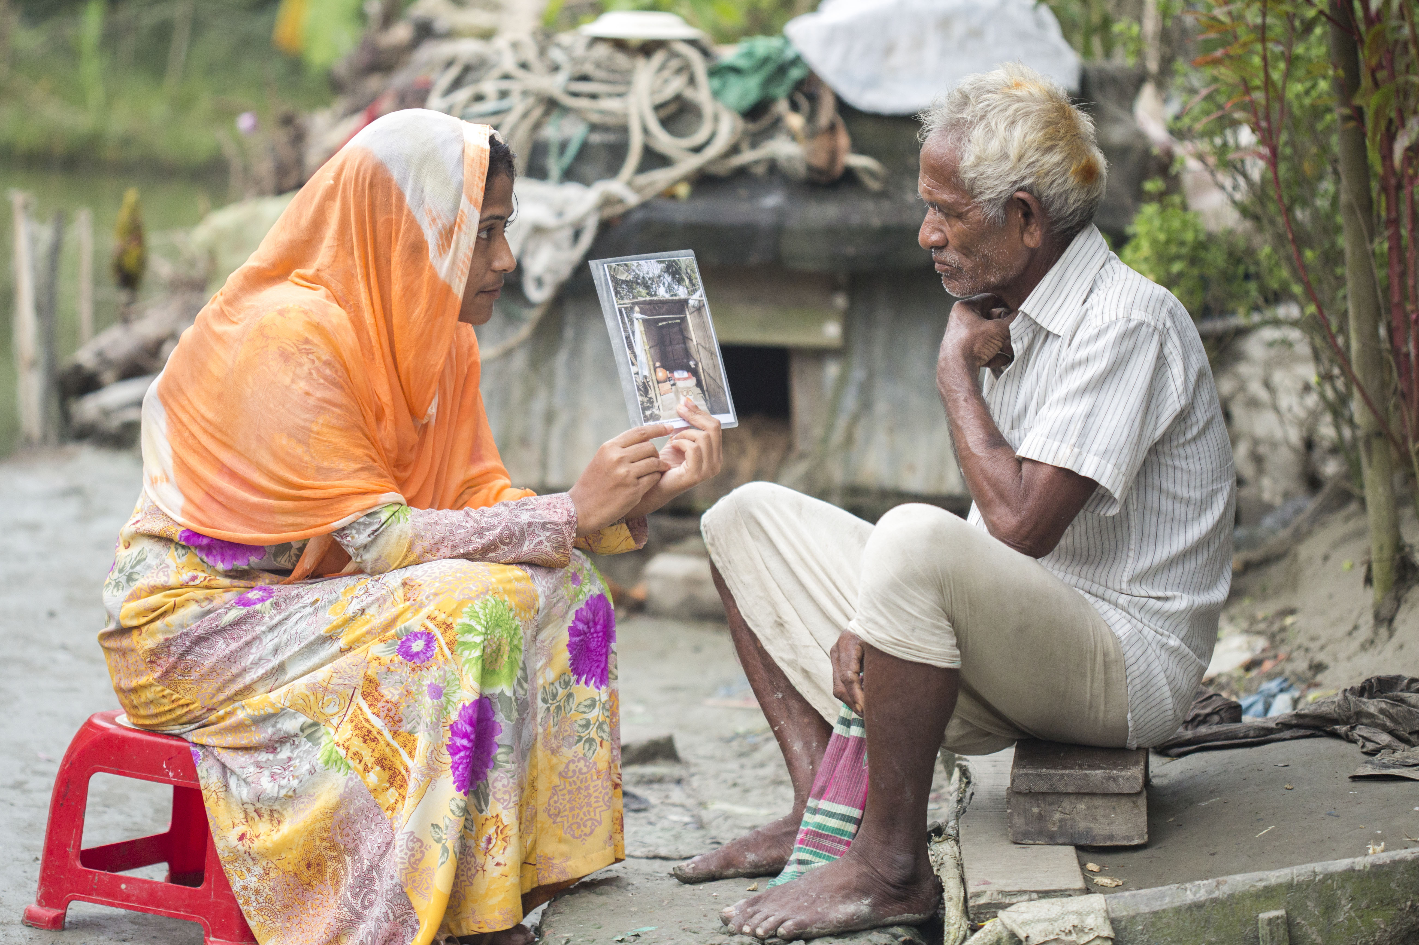
Schooling/Awareness Campaign for Water and Sanitation: The organization HASI is implementing Hygiene, Sanitation and Water Supply program since its inception. At present HASI is implementing this program with Financial support of HYSAWA program awareness program school level. School Satiation & Hygiene Education School visit, Follow up Student Brigade and 1 days teacher's/SMC orientation.

Social Mobilization for Awareness Building Activities: Community meeting (PRA Method), Court yard meeting, Cluster/Community action plan (CAP) preparation through PRA Method, Tea-Stall session on Hygiene Education, Household visit to improve Hygiene practice, Cluster map preparation through PRA Method to identify the community problem & demand create from the bottom level, Video Show, WATSAN fair & Demonstration low cost latrine with hand wash device.

Safe Water Supply: New water place selection, Water user group formation, Technology selection, Assist to community for water & construction quality.
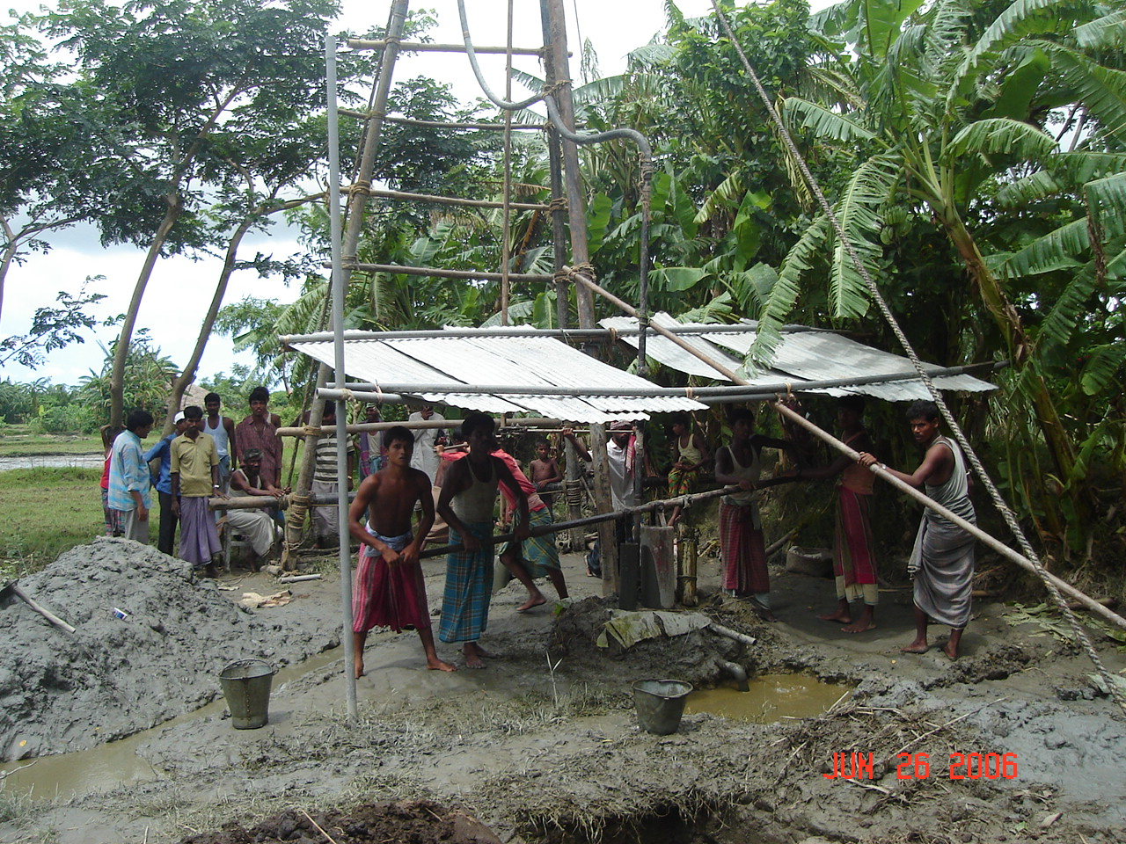
Deep-Tube-well installation :
Project area 6 union HASI installation 490 Deep-Tub-well for supply safe water for the community people.

Pond : In the project period HASI re-excavation pod for safe water.

Tree plantation : In the period HASI group member plantation different tree plantation for environment, wood and foots.

Climate Change: The project period 6 union disaster management committee develop capacity preparation disaster plan and adaptation capacity for any disaster. Total project beneficiaries 32600 family.

Water, Sanitation and Hygiene
Objectives : To reconstruct sanitation facilities for the vulnerable people affected by cyclone Aila
Activities:
- Identification of beneficiaries
- Develop design for sanitary latrines.
- Procurement of latrine materials
- Construction and installation of latrines
- Awareness campaign on health-hygiene issue and uses of sanitary latrine and maintenance.
- Coordination and monitor work progress and effectiveness

Achievements up to till date:
- 325 beneficiaries (including 25 extended) were selected those who are also for shelter beneficiaries.
- Design of latrines have completed;
- 325 sets of latrines construction & installation have been completed and handed over to the beneficiaries. CARE & HASI closely monitored the actives for ensuring the quality.

Market Systems (ERMS), Cash for Work
Objectives :
To generate income through cash for work for vulnerable people affected by cyclone Aila
Activities:

- Identification of beneficiaries through FGD for enrolment 500 severely affected poor and marginalized people
- Formulation of PIC to implement the CFW schemes
- Selection of houses for plinth raising
- Formulate CFW scheme plan
- Engage beneficiaries in CFW schemes.
- Distribute wages accordingly
- Coordination and monitor work progress and effectiveness
Achievements up to till date:
- 500 beneficiaries were selected through maintaining selection criteria.
- 325 household selected for plinth rising and have been completed the work.
- 325 CFW schemes pre & post measurement completed. 500 beneficiaries engaged in CFW works and by thus15983 person days employment generated. (each person received tk 150/ ($ 2.2) per day
CARE and PNGO team monitored the CFW activities regularly.

Vulnerable Group Development (VGD) Women Program

In 2015-2016 HASI Implement VGD program Hatiya, Subornarchar and Kabirhat Upazilla under Noakhali District.

Thr project objective promote the socio-economic and cultural upliftment of the poor and vulnerable people, especially the poor and landless people, emphasizing the hardcore poor, river erosion people, shelterless family, vulnerable women, disabled, children, landless farmers, fishermen communities through conscienrzation, capacity building, institution build and capital formation and imparting felt-need based problem solving programs. It believes in non-directive, bottom up, integrated and participatory development frame work and acts as a catalyst with its concerned people.

BPUS has signed an agreement with the Department of Women Affairs Program for the period 2015-2016 for 3 upazila (Hatiya, Subornarchar and Kabirhat Upazilla) under Noakhali District. Already we have stared project activities from the period for the rehabilitation of the vulnerable groups i.e. VGD women card holders through awareness training, skills development training, organization savings groups and providing micro-credit support. After signing, the organization has been taken initiatives to implement the project in the project areas among the VGD women card holders through involving skilled and experienced staff members, volunteers and group leaders under the guidance of different related government departments. The following activities have been done up to the inception reporting period according to the agreement of the project activities implementation.

Sharing With Government Concern Authorities, Project Staff and Executive Committee Member of HASI:
After signing the agreement HASI sharing the project goal, objectives, activities and expected outcomes were shared with the senior staffs of the organization and prepared break up budget and action plan to implement the project activities at the field levels and other necessary preparations for starting the project activities. BPUS sharing with the Government Authorities Hatiya, Subornarchar and Kabirhat Upazilla Women Affairs Department and Noakhali District Women Affairs Department.

Staff Selection:
As per agreement HASI selection necessary project staffs are involved with the project like- Project Coordinator, Trainers, Assistant Trainers, Accountant for smoothly and effectively project activities down. After involvement and orientation workshop conducted by the implementing agency on the project goal, objectives, activities, expected outputs and implementation strategies, by which they can carry out their duties and responsibilities smoothly and effectively.

Orientation to the Project Staff: After appointment the project staff were provided orientation on the project thoroughly and prepared action plan to implementation the project activities at the Upaziilla levels with clear conception about the project goals, objectives, activities, expected outputs, implementation strategies, monitoring etc. by which they can implement the project very effectively and other necessary preparations for smooth and effective implementation.

The Staffs development:
After training, the project staffs have placed in four project Upazila like- Hatiya, Subornarchar and Kabirhat Upazilla under Naokhali District to perform their duties and responsibilities according to the agreement.

Meeting with UP member and Beneficiaries List Collection:
The project have met with the UP Chairman and Members of related Upazilla and collecting the list of VGD women members and they have also met with the Upazilla Women Development Officers to collect the list of VGD women members. Soon they will meet with the VGD women members and discuss with them about the program.

Total Beneficiaries in the Project:

Sl. No. | Upazilla | Union No. | Total Beneifciaries No.
01. | Subornarchar | 8 | 1210
02. | Hatiya | 11 | 1428
03. | Kabirhat | 7 | 1209

Group Formation:

Sl. No. | Upazilla | Total Beneifciaries No. | Total Group No.
01. | Subornarchar | 1210 | 48
02. | Hatiya | 1428 | 57
03. | Kabirhat | 1209 | 48

Group Saving Collection:
Sl. No. | Upazilla | Beneficiaries Savings | Savings Target | Total Savings Collection
01. | Subornarchar | 1210 | 847000 | 720650
02. | Hatiya | 1428 | 999600 | 749700
03. | Kabirhat | 1209 | 846300 | 647650
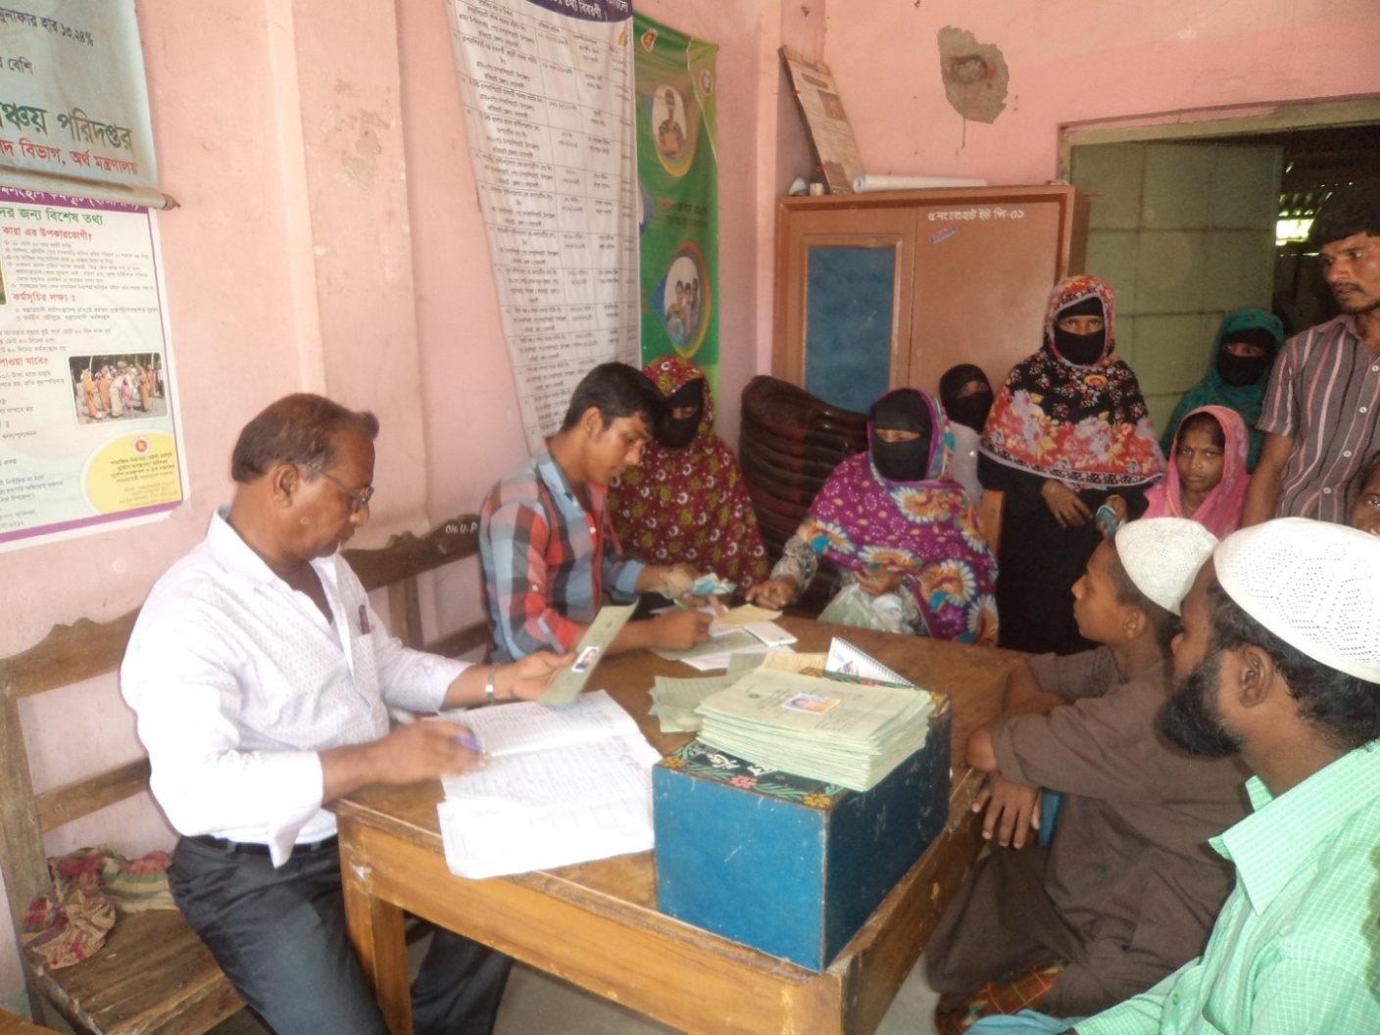

Beneficiaries Capacity Building Training
Sl. No. | Name of Training | Upazila Wise Beneficiaries
Sl. No. | Name of Training | Subornarchar |  | Hatiya |  | Kabirhat
 |  | Target | Achievement | Target | Achievement | Target | Achievement
01. | Entrepreneur Development | 1210 | 1089 | 1428 | 1220 | 1209 | 1078
02. | Cow and Gate Rearing | 1210 | 200 | 1428 | 240 | 1209 | 209
03. | Hen and Duck Rearing | 1210 | 401 | 1428 | 350 | 1209 | 300
04. | Homestead Gardening | 1210 | 299 | 1428 | 320 | 1209 | 195

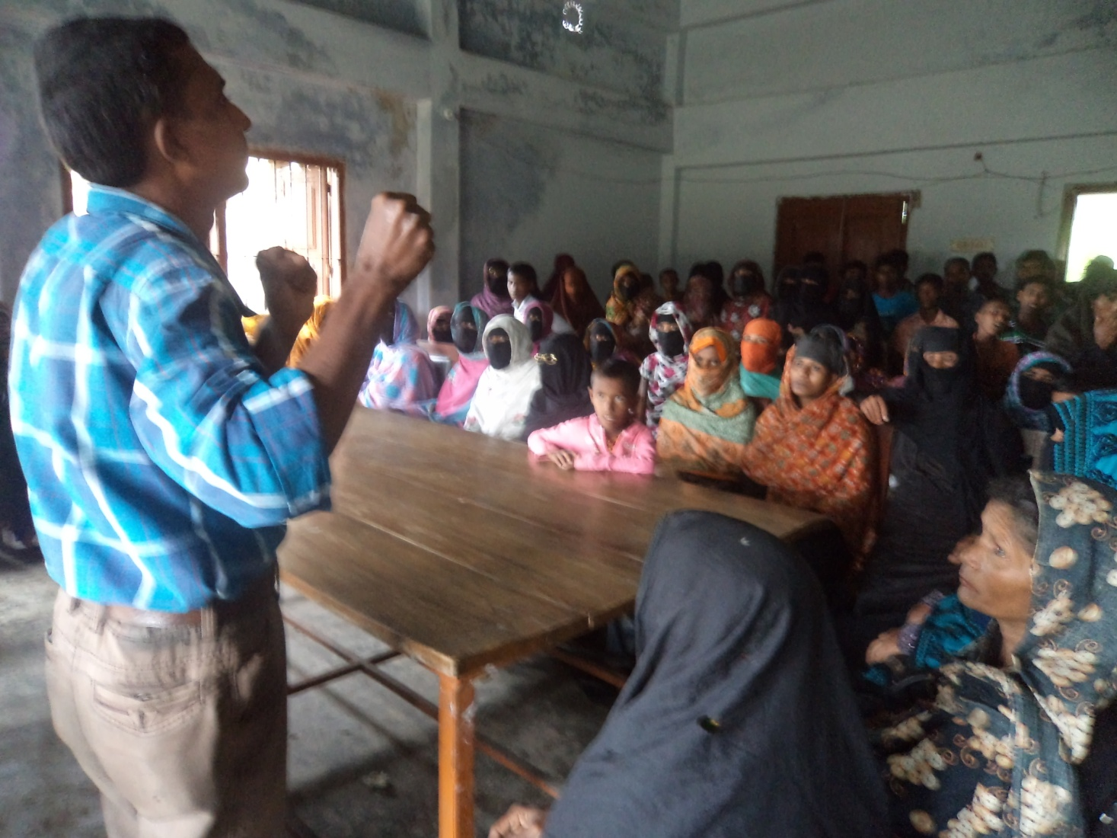

Goat Rearer ~
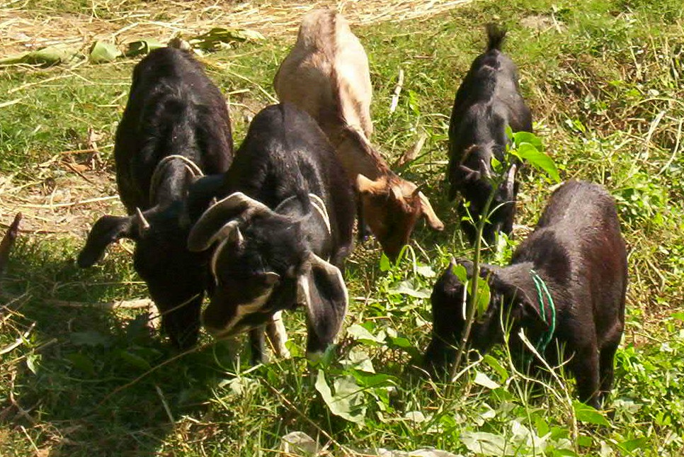
Training~
Selected 110 Goat-Rearers received one-day training on appropriate techiqunics for rearing, feeding, housing, de-warming and prevention of primary diseases facilitated by Group Facilitator (Poultry & Livestock) with the help of Sector Specialist.

Beneficiaries Rice Distribution:
In the project period HASI distribution rice for the beneficiaries.

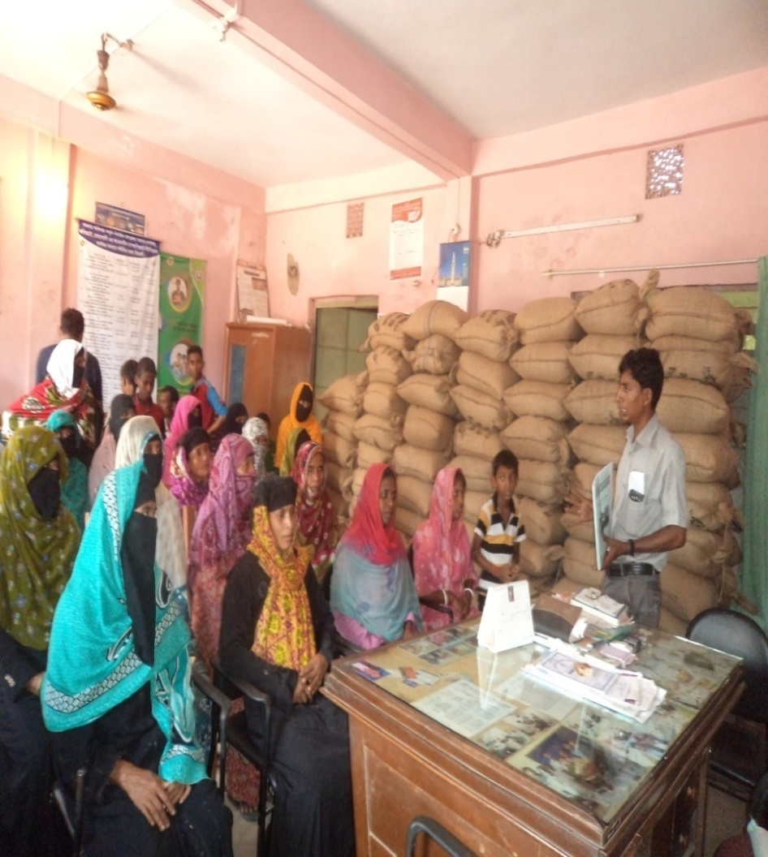

In fine, we can conclude that in the inception period, the project performance is satisfactory. So, we are very much thankful to our staff and other related stakeholders, who have been cooperated and cooperating us for better implementation and effectiveness of the project. If we get all sorts of cooperation from all sides, we believe, the project implementation will be fruitful and benefit the poor VGD women members for rehabilitation. We cordially hope, it would be possible for us to implement the project activities effectively and benefit the project beneficiaries.

Disaster Management

Rally on disaster day~

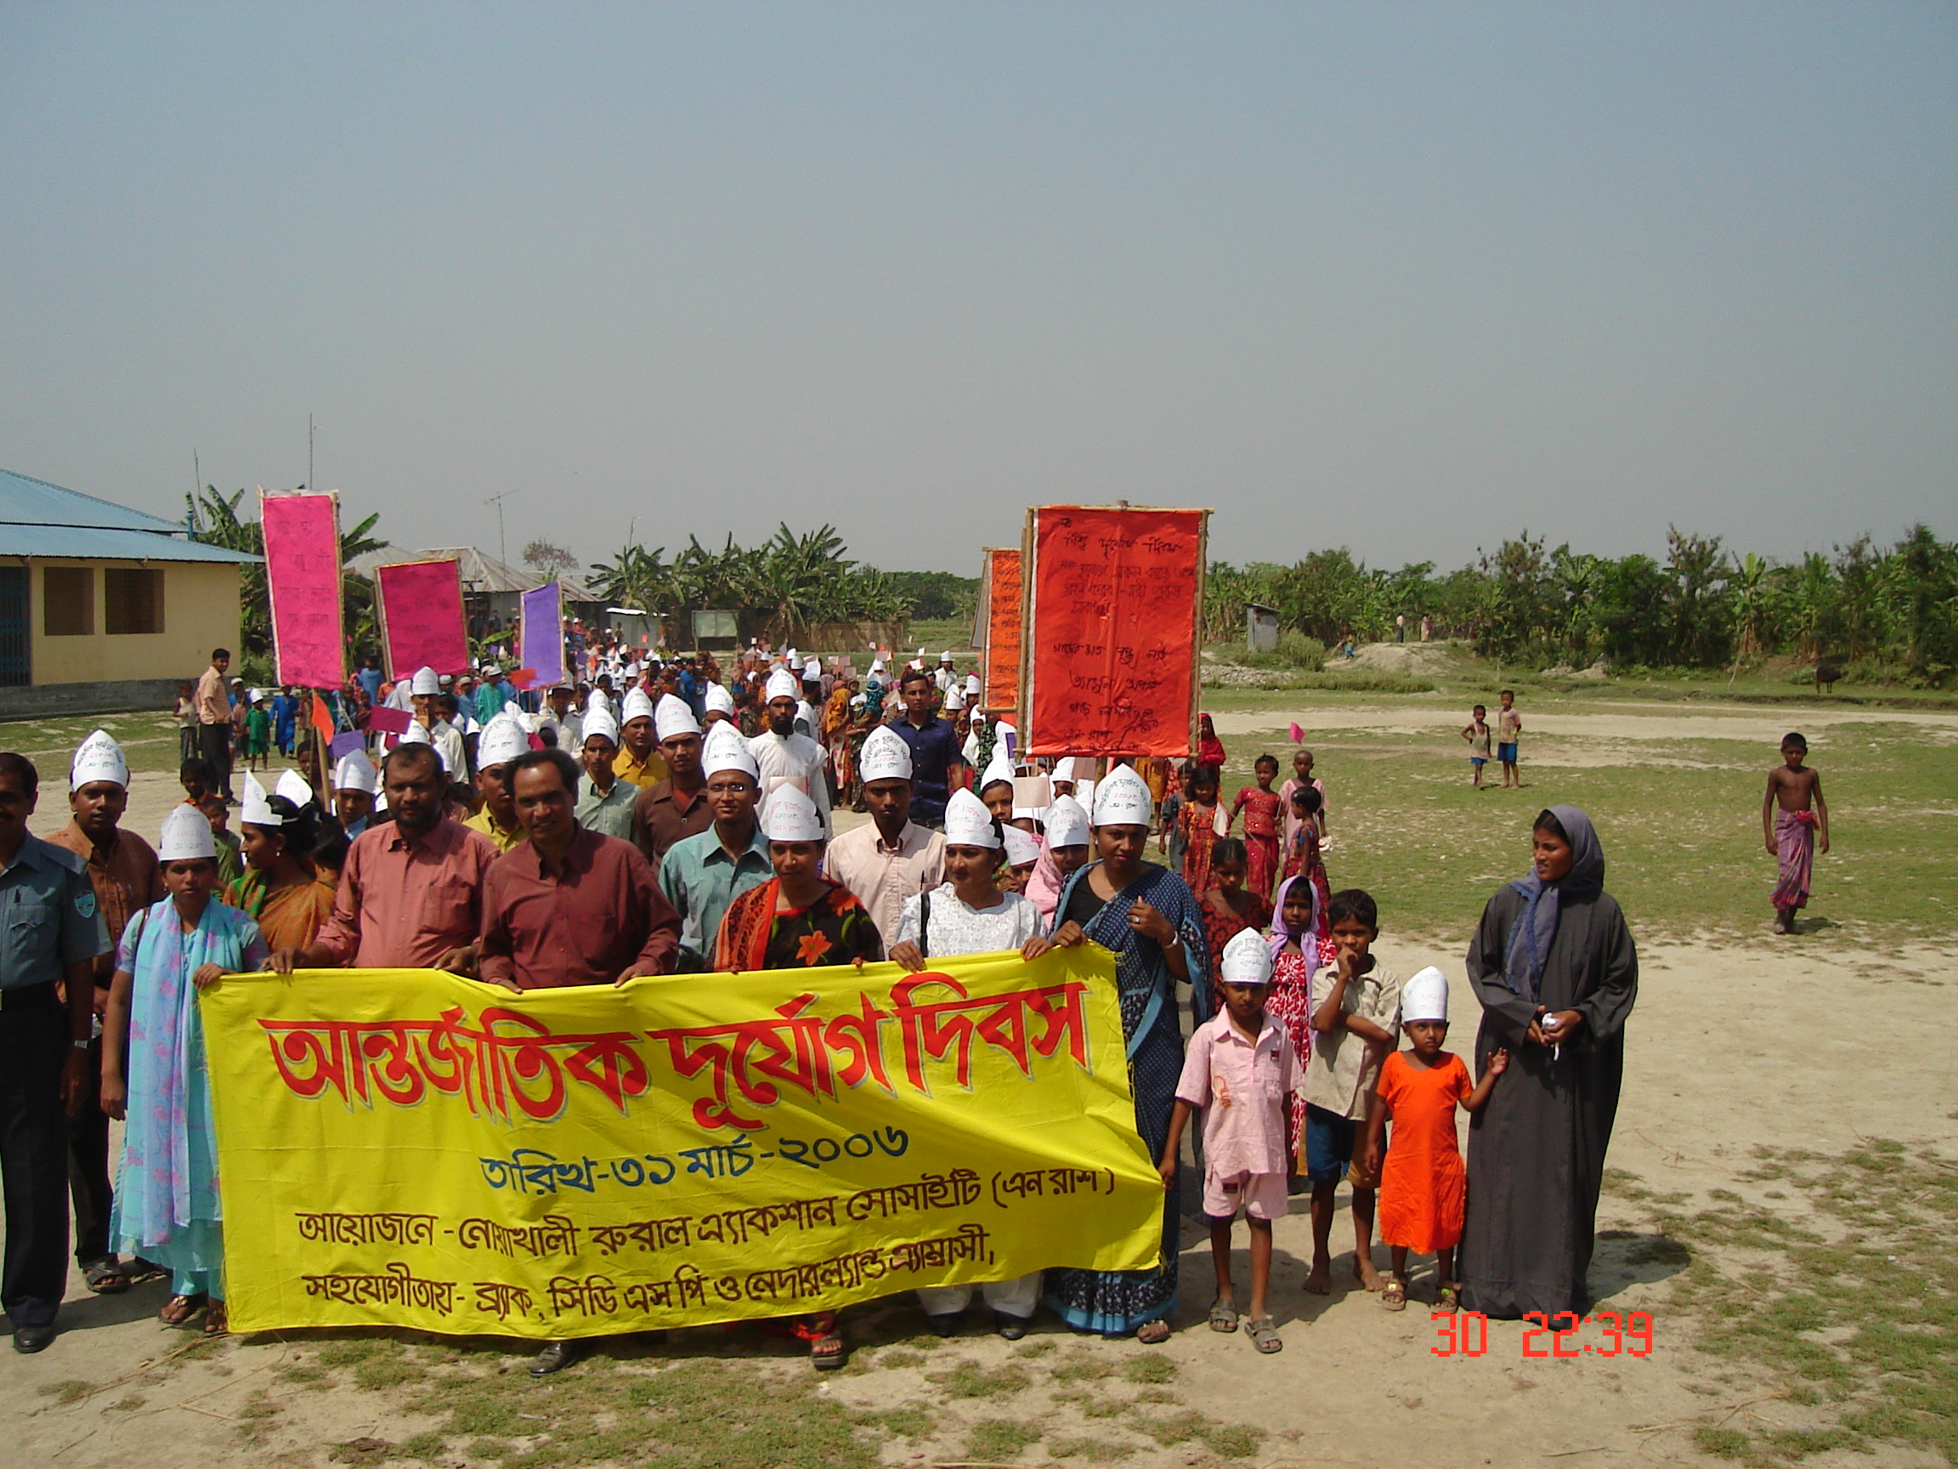
There has the probation to observe the disaster day in our project. Colorful rally was arranged in this regard. HASI organized the rally in every year on disaster day. The students of different school, madrasha, teacher of different institution whatever are there in Boyer char. The rally walked on the main road of the island holding banner and festoon in their hand. The participants also uttered some slogans in the rally to raise awareness among the people. . After rally there conducted a discussion meeting in the office. The Representative of the HASI other speaker had discussed in the meeting. The speaker of the discussion meeting stressed on to protect the disaster and protect resources from the same. Two rallies were arranged in the reporting period August’06 to June 2011.
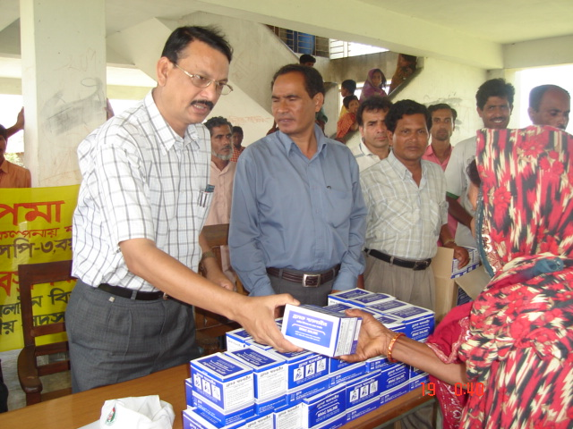
Saline Distribution:

There was insufficient water and sanitation system in the area. People used to drink water from river, dishes and tidal. Due to lack of sanitation and safe water huge number of children dies on sudden out break of diarrhea in the area. It was seen from the study different organization that there were lot of health hazard in the char area. Keeping all the odds HASI kept the probation to distribute the oral dehydration saline among the beneficiaries in the area. All the beneficiaries in the project area will get the facility. In the reporting period all the beneficiaries those enrolled in the group got the saline twenty packets each. A total 320000 packets of oral saline was distributed in the reporting period August’06 to June 2011.

Activities carried out in the details with photographs :

Staff Orientation:
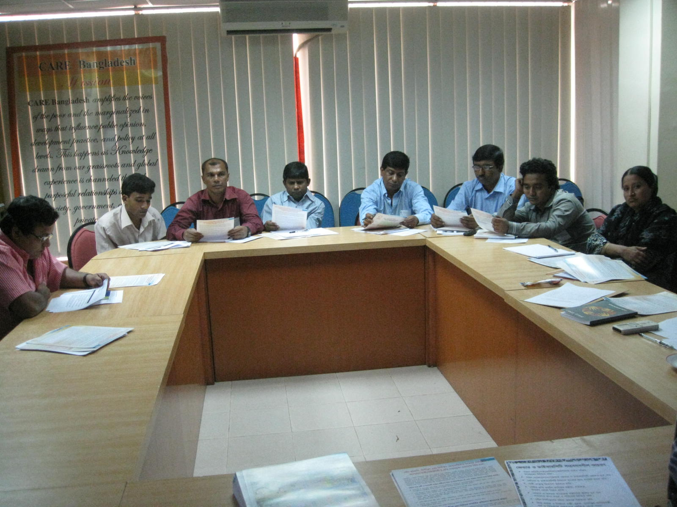
Just before starting of the project CARE Bangladesh organized a day long staff orientation in the CBHQ. Whole orientation conducted by Emergency Response Co-coordinator M.A. Wahed. Total 6 no`s staffs including ED of HASI and PM AILA Rehab Project HASI conducted the orientation along with CARE Personnel Project Engineer and Project Monitoring Officer. Emergency Response Coordinator welcome to the participants from CARE Bangladesh and stated day schedule to the participants. Following schedule he discussed about Project Goal, objectives, outcomes, sphere and Hap and beneficiaries selection criteria as well as total project implementation guideline. Partnership, Gender Issue, Procurement, accounts and Audit issues were discuss by the sect oral Facilitator from CARE Bangladesh.

Upazila Inception Workshop

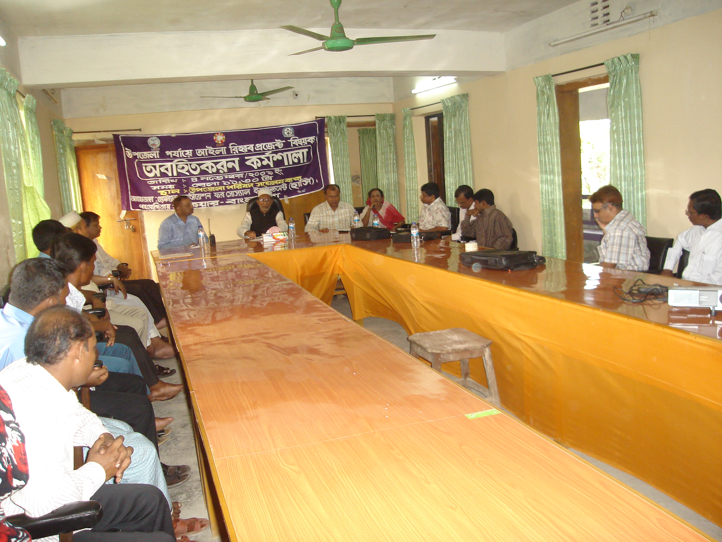
HASI AILA Rehab Project organized Upazila Inception Workshop at Upazila conference room. Upazila Chairman, UNO, Upazila Vice Chairman Female and Officer In charge of Hatiya Thana were present the workshop Respectively as Chief Guest and Special Guest. Akram Hossain Rumi ED of HASI presided over the workshop. Upazila Vice Chairman Female thanks to the HASI & CARE Bangladesh to take such a project and urges to the HASI for Showing good performance and he proposed shelter may be develop in the individually or cluster wise like colony / Polly. Officer in Charge Hatiya Thana Congratulate the HASI and CARE Bangladesh for there great initiative to reduce vulnerability of the AILA Affected people of Nijhumdwip. He assured that all shorts of assistance will be given to the HASI for better implementation of the project. UNO of Hatiya Upazila also thanks to the HASI and CARE Bangladesh for taking there great initiatives for the AILA affected people of Nijhumdwip.

Union Inception Workshop

HASI AILA Rehab Project organized Union Inception Workshop on 10th November 2009 at Nijhumdwip Union Parishad Hall room. Administrator of Nijhumdwip Union Parishad, Union Parishad Members, Civil Society, HASI and CARE Representatives were presents the workshop. Nijhumdwip Union Parishad Administrator was the Chief Guest of the workshop. Project Engineer, CARE Bangladesh Presided over the workshop. Total 35 nos of participants were present the workshop. 8 Members of Nijhumdwip Union, Elides, Poor & Extreme Poor Representative were present the workshop, CARE Personal Monitoring Officer and Others People NGOs and CBOs present the workshop. Project Manager of AILA Rehab Project conducts the workshop with the participation of the audience. Project Briefing session is conducted by PM through Poster Paper. In the open question session, a few participants asking some questions on Project beneficiaries Specially on Shelter, Sanitary Latrine & CFW Beneficiaries. Project Manager replies the question as per project guideline. Union Parishad Administrator thanks to the HASI & CARE Bangladesh to take such a project and urges to the HASI for Showing good performance and he proposed shelter may be develop in the individually or cluster wise like colony / Polly. CARE Bangladesh Project Engineer Mr. Abdur Rahman concluded the workshop with thanks to the all participants.

Community Consultation
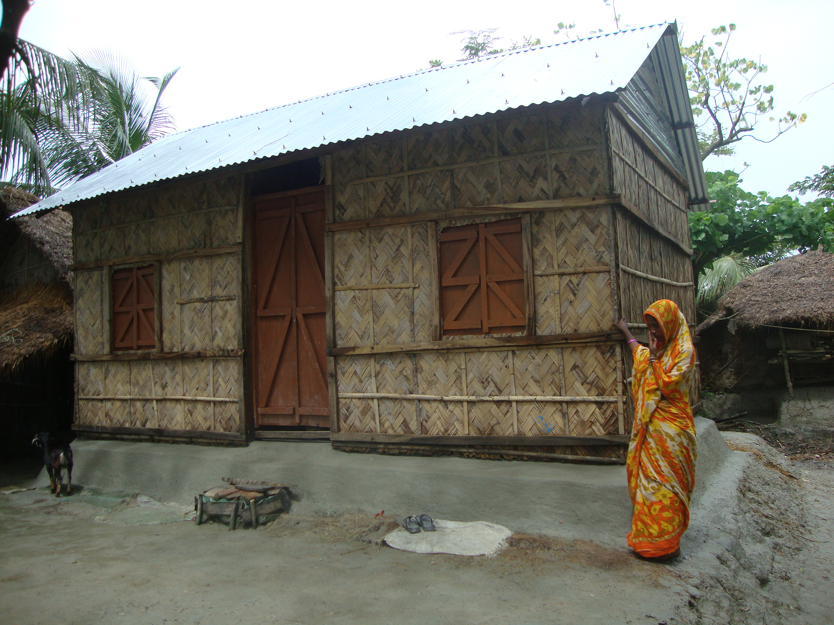
Community consultation is the process of taking peoples opinion and participation to achieve project goal and objectives. CF and Monitoring officer of HASI have visited the whole Nijhumdwip and discussed with the different groups of people to select the most affected community. After selecting 8(Eight) community as per peoples consent HASI organized 8 community consultation that’s conducted by the CF along with Monitoring officer and Care personnel as well as project manager. Total 1250 participants attended the consultation and give their opinion to prepare social map and analyzed vulnerability of the community. As a result we got the two finished product from the community consultation. One is the social map of the each community and another is the base line list with WBA.

Shelter Construction.
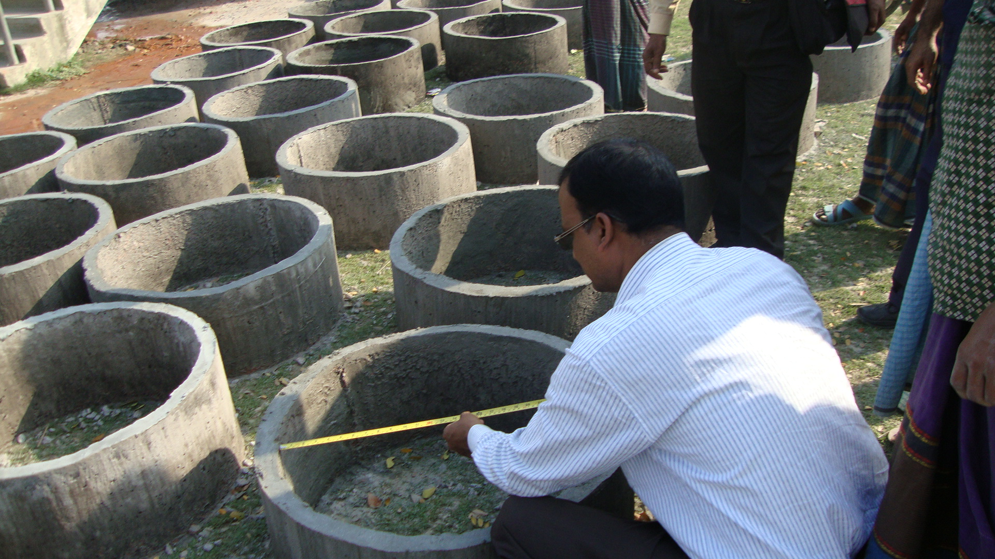
The main activity of the project is family shelter construction for the 300 cyclone Aila affected poor and marginalized households at Nijhum Dwip. By July 2010 construction of 300 shelters were completed. PNGO & CARE monitoring team are closely monitoring the progress and quality of work and quality of materials as well. It is regarded that the design and quality of the housing materials evolved through practical experiences.

Sanitary latrine construction & installation
Construction of sanitary latrine for the 300 cyclone Aila affected poor and marginalized people at Nijhum Dwip is another vital intervention of the project. Within the reporting period installation of 300 latrines were completed maintaining the quality. Side by side of the construction works, the PNGO & CARE team has been completed the awareness session on health & hygiene issues through court yard meetings. Six best practices regarding health & hygiene were discussed in the sessions along with the use of latrines. The monitoring team monitored both the latrine construction works & awareness sessions closely.

Cash for Work for plinth raising
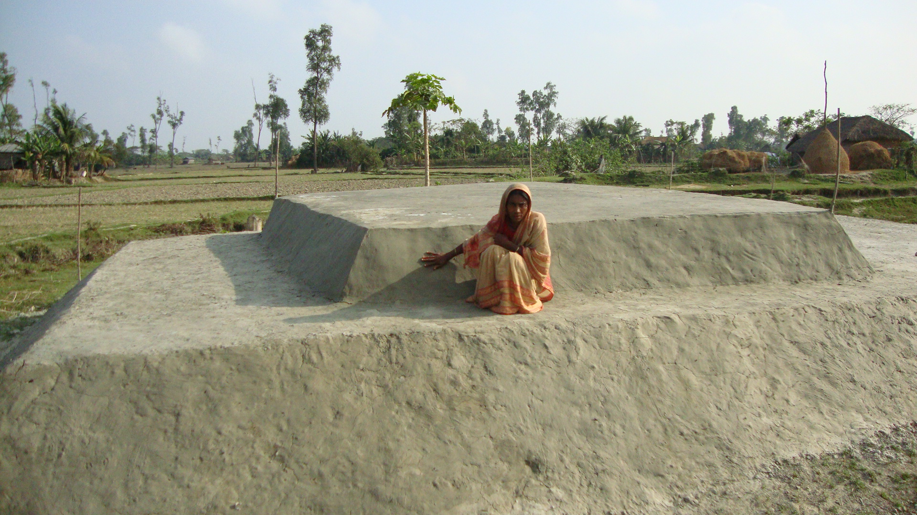
Other than fishing and seasonal farming the people of Nijhum Dwip didn’t have any significant income option. After cyclone Aila, scope of doing farm and off farm activities narrowed further and as a result peoples access to food and daily necessities become limited. In these circumstances, when people were desperately moving out from Nijhum Dwip for income earning, HASI with technical support from CARE Bangladesh started CFW activities and engaged 500 beneficiary labors for 30 days from affected poor and marginalized. Through this undertaking a total 300 houses’ plinths were raised using 15000 person days which incurred a total BDT 22,50,000/- . PNGO & CARE-Bangladesh monitored the quality of CFW schemes. Both male and female were given equal wages (tk.150.00). Total 281 male and 219 female were engaged for CFW works.

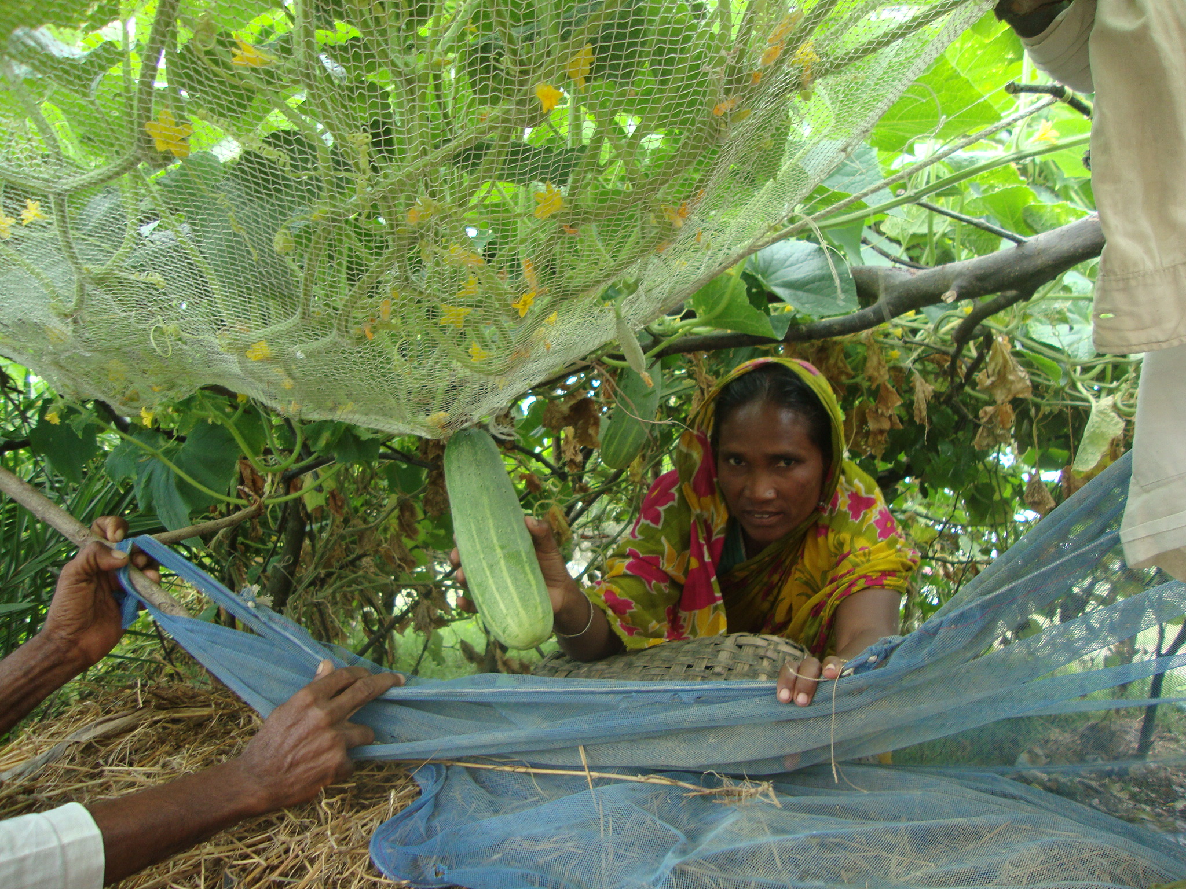
Immediate results: By doing CFW work each family got an average BDT 4500 and with this wage money they met their daily needs and saved about BDT 1500 to 2500 amount. Most of the beneficiary started income generation activity like poultry and goat rearing. They cultivated home stead vegetables at the raising ground, planted trees. Some of them are selling vegetables and earning revenue. During CFW work earths were collected from ditches and as bi-product of the activity some small ponds were created which are being in use either for fish culture or for drinking/washing purposes.

HASI- BRAC- CDSP-III Program
Major Activities

Major activities of the projects and highlights the key achievements during the reporting period.
1: Polli Samaj
Capacity development:
Skill is an essential tool to provide services to the people. HASI put the highest priority to the training of staff and beneficiaries to develop their capacity and skill so that they would be able to ensure the best services to the people they needed. HASI arranged various type of training and orientation to develop their capacity and skill where needed and will continue up the project period.

Staff training:
The project aimed to develop the capacity of the staff in Polli Samaj program. A total twelve staff got the training on Polli Samaj program.. Only a staff will work in Polli Samaj program but two was developed in this regard to disseminate the program message to the beneficiaries and other stakeholders where get the opportunity.

Activities had done in the reporting period~
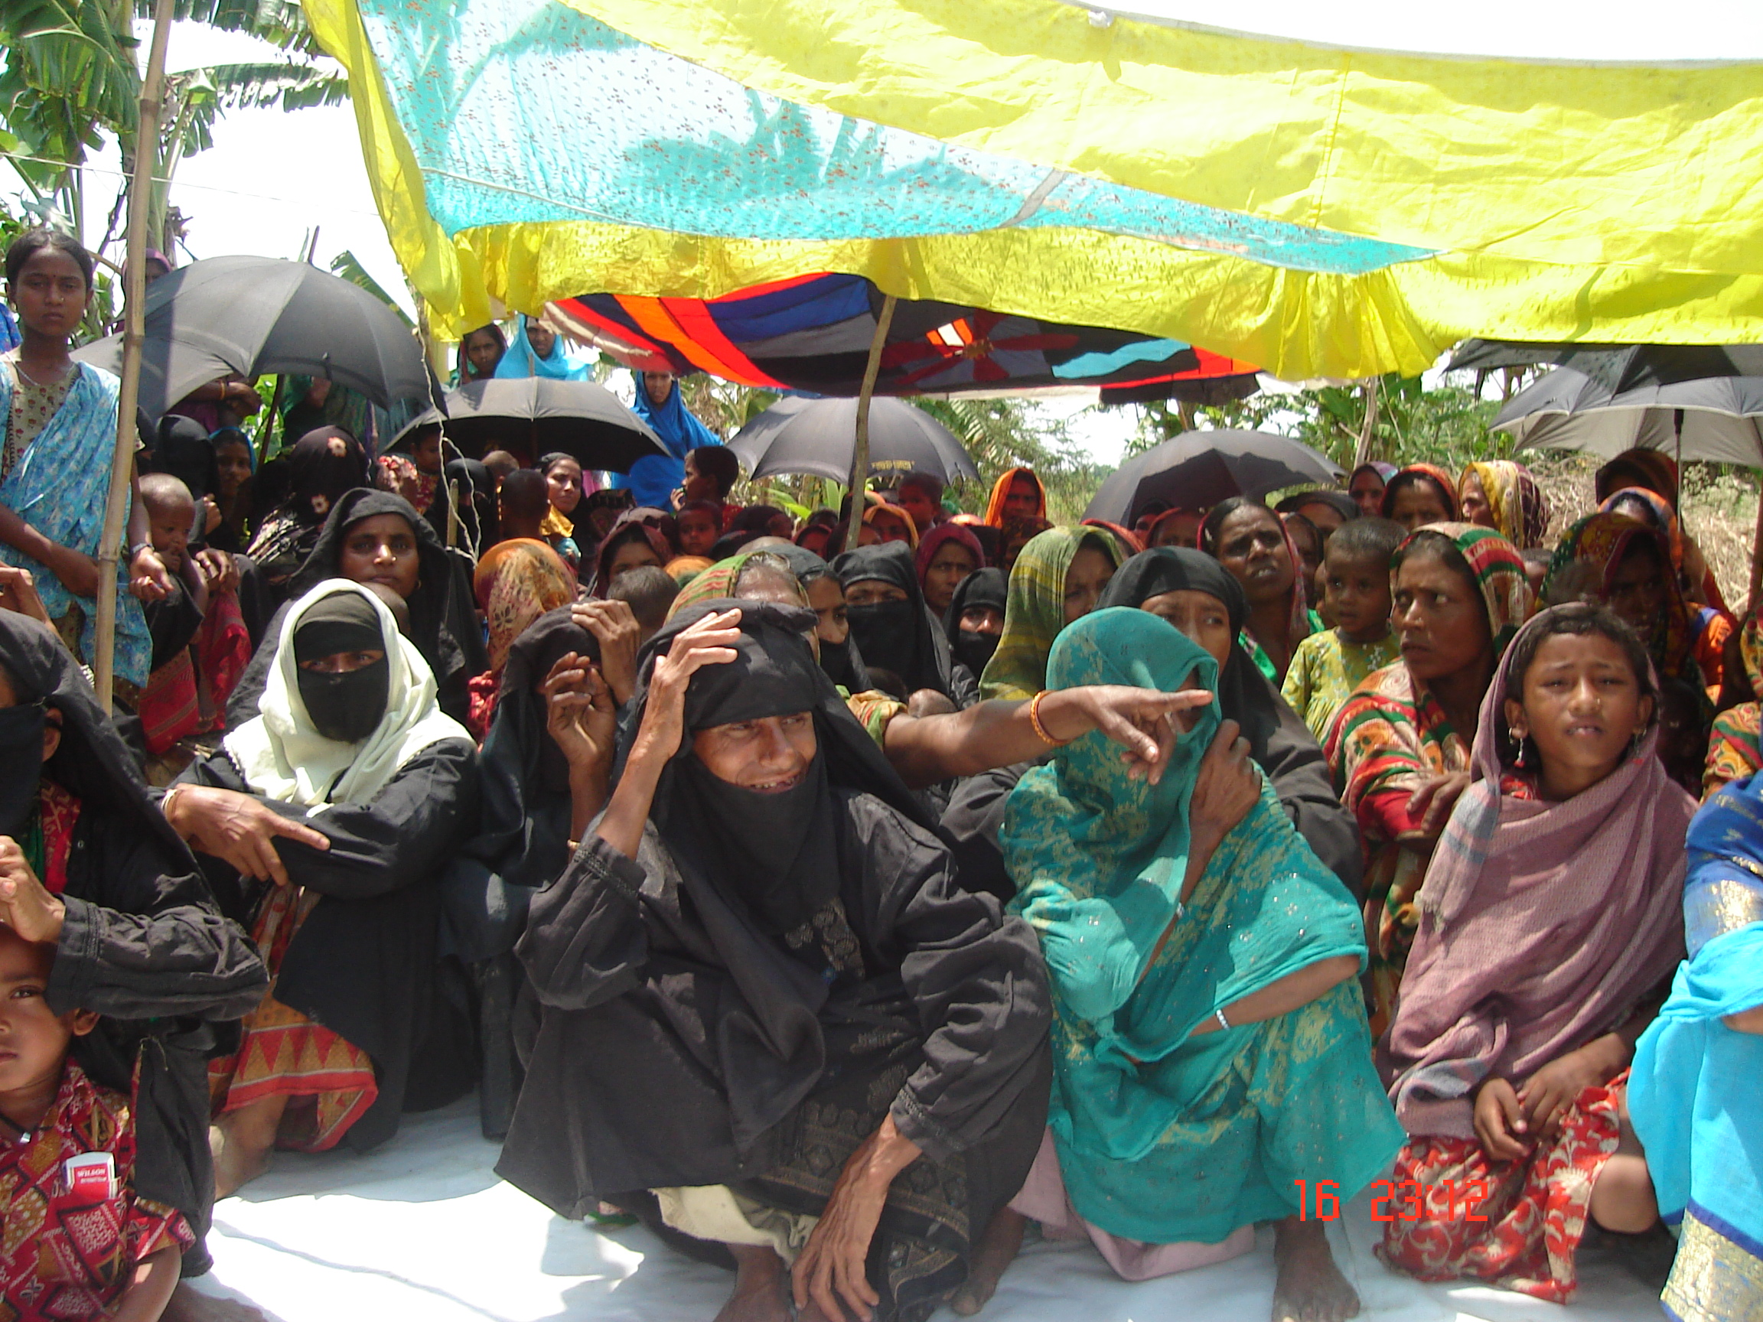
A polli samaj is formed with five groups that is the free federation consisting of 15 members managing committee. A polli Samaj is formed taking three members from each of the savings and credit group. The task of the Polli Samaj is to identify the khash land and government resources. They will work for good governance keeping close relation with the member of local government unit. The member of the Polli Samaj will try to make the people aware to eradicate all type of irregularities from the society. A committee is formed in each Polli Samaj group is known as managing committee. The committee will meet with the member of the polli Samaj once in two month. They will discuss about the present problems prevailing in the society and the progress of the activities they have to done within the framework.

Human Rights and Legal Education:

Boyerchar is a very neglected area in the char areas of Bangladesh. Moreover, the social settings and legal status is also very poor. The women of these areas are deprived of many rights, which they are entitled to by birth. The fundamental religious groups dominate in all spheres of the social settings at the area.
These people are not very much knowledgeable about religion and misinterpret religious norms and use them in their own benefits. Early marriage, dowry, divorce, separation, multiple marriages and torturing on the female are very commonly observed in the life of the char people. Women are victimized here. Gradually these women have started considering them to be inferior to men and put up with all torture. They have accepted this to be their fate and adjust with this situation, no matter what it takes to do so. With a view to end this situation HASI decided to adopt this program in this project.

Staff Training~
The project is aimed to capacity development for the staff working under this head. Two staffs received training on human rights and legal education program. These trained staff of HRLE attends groups formed for credit operation on a regular basis and disseminate information -legal matters, human rights, laws of social life, etc.

HRLE Sebika training~
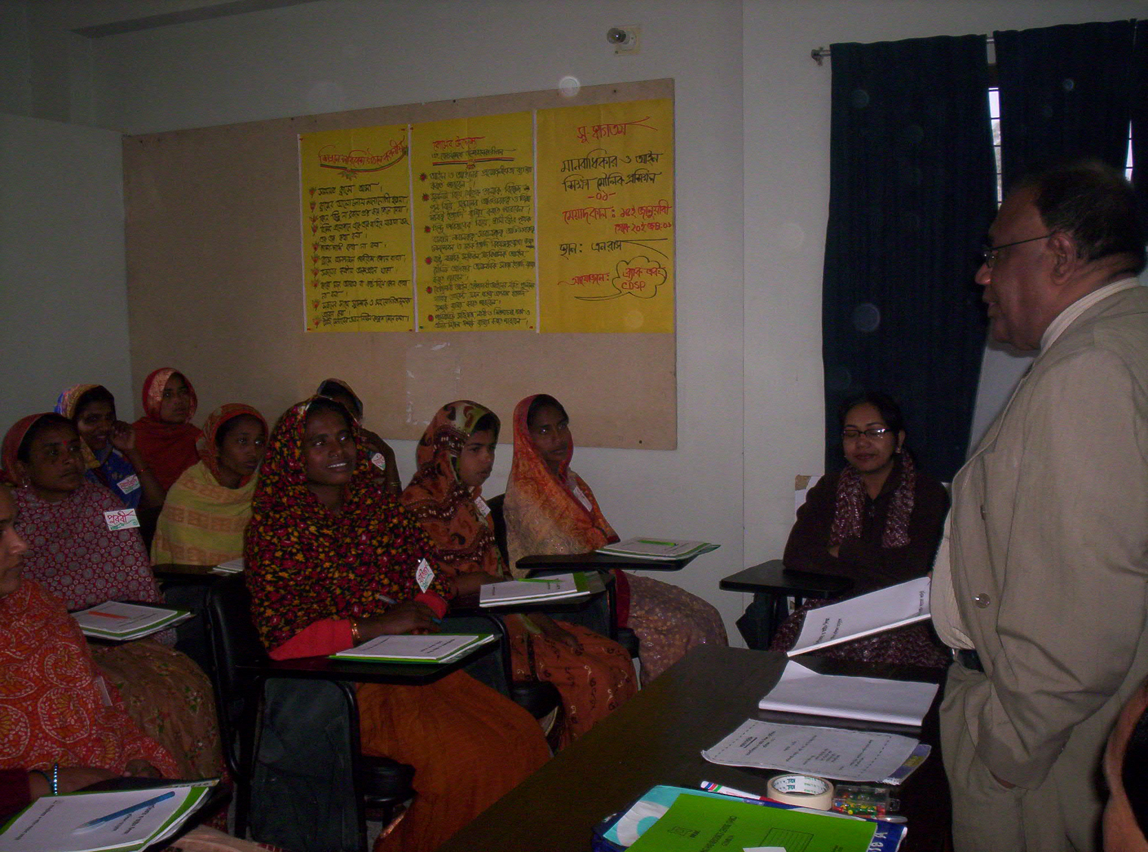
A total 06-group member will be developed to work in the community level. Each Sebika will work with 250-house hold. The trained members were given training on Muslim familial law, Hindu familial law, and Succession law of both Muslim and Hindu, Criminal law, Land law, Constitution law during twenty four days. On the last day of the training an evaluation was made to see the post training knowledge among the trainees. A total 1010 members were developed in this sector in the reporting August to June 2010.

Inputs to the HRLE Sebika~
After training the entire HRLE Sebika was called for orientation on how they will work in the field and how they will maintain the record of the work they usually do. More over proper guide line of work was given on the day of orientation. Each HRLE Sebika was given four registers to keep the record, a bag and flip chart was also given as inputs.

Classes conducted by the Sebika~ The each HRLE Sebika will conduct a course in thirty days in each group. Each participant of the class is to contribute Tk.10 each for course fee. All the classes will be held in the after noon session.. The class duration in day is two hours. There would be a mid term evaluation at the 15th day of the class by the respective staff and Field coordinator of HASI. Final evaluation will be held on the end of the course. After completion of the course a law implementation committee will be formed that will take over any kind of irregularities and step to be taken for justice.

Local community leader (LCL) Workshop~
The community leader workshop held in the community level. This initiative is to involve the local elite to implement the program more smoothly. The main objective of the workshop is to involve the local community in the process of changing existing social practice that goes against law. The participants of the workshop are the existing union parisad chairman, member, imam, kazi, local elites, HRLE sebika, and president of polli samaj, school and madrasha teacher. Respective staff of the program and field coordinator of HASI is also the participants.

Refresher training~
HASI arranged intensive training package for the staff and beneficiaries of the project to develop human capacity and skill. On the other hand HASI believes that there should be some arrangement to review the training contents and to share the experience and odds prevailing in the project area. Because HASI is arranging refresher training for the beneficiaries once in a month. In the refresher training the trained participants participate and share the experience in the whole day. Less achievement gained in case of participants because the participants could not attend the refresher due to illness and familial reason.

Health & Family Planning Program:
Boyerchar is a backward and neglected area, devoid of proper health facilities. This project introduced a number of health and family planning services to the char dwellers. Before the project intervention in the area, only one NGO, Unnayan Parikalpanay Manus (UPOMA) was working in the health sector with financial aid of CONCERN Bangladesh. But UPOMA could not cover all the char areas. Therefore, HASI planned to launch health program with the support of BRAC to help the infants who die of diarrhea and also to provide other family planning, health services to ascertain better living in the char area.

Initially, there was no mentionable government or non-government organization working in this sector on a permanent basis. The government health services were available at the union level only, thus inadequate compare to the need in the areas. There are nine immunization centers operating in the chars. The services under the project include health services and health education by the medical assistants, (Shastha Shebika), free distribution of contraceptives, maternal services, etc.

Capacity building~
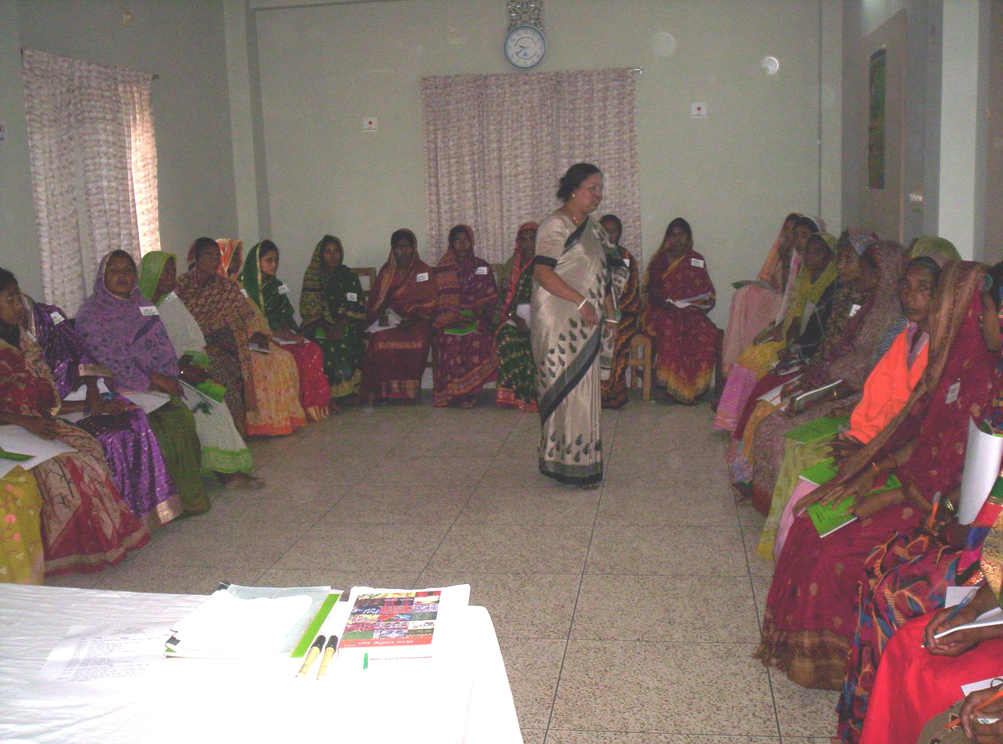
Five staffs received training on health services and family planning. These trained staffs disseminate health related information and involve aware building activities through the groups of VO members. All these staffs are regular attendance of group meetings where they actually communicate with the target group.

Shastha Shebika Training~A total of 12-shastha shebika (SS) will be trained to work in the community level. Each of these trained SS will be responsible for 150 households in her area. Each Shastha Shebika got training on Sanitation and Safe water, Personal hygiene, Environmental issues, Child and mother health, Immunization, Tuberculosis, Nutrition, Family planning, Treatment of ten common diseases, etc. The training is an 18-day training and at the last day of the training evaluation is made of all the participants.

Each Shastha Shebika (SS) receives Tk.700 cash, a delivery kit, sanitary napkins, medicines for ten common diseases, a medicine bag, a register etc after training. She visits 150 households (approx) in her demarcated area to guide general public on family planning, basic health issues and treat ten common diseases. After proper training these SS are called on to their respective joining areas and are given one-day orientation as to how they would implement their job, how to maintain register, how to keep record, etc.

Traditional birth attendance (TBA) training~
Maternal health is the most neglected health sector in Boyerchar. There are only two hospitals one at Char Jabbar and the other at Maijdi. These are approximately 25km and 60km away from Boyerchar respectively. All delivery related complicated issues are referred to these hospitals. Moreover, transport system is very poor. Keeping all these odds in mind HASI designed plan with BRAC to train traditional birth attendants so that basic maternal health care services can be provided in the community level in the project area.

A total of fifty-group members were selected for training in view of the following criteria:
- Must be a member of a group.
- Must be above thirty-five years aged.
- Priority may be given to those with prior work experience in similar sector.
- Willing to work in the community.
Week long training is provided to these TBA on maternal health issues, such as appropriate marriage age, right age to become a mother, antenatal care, post natal care, complication during pregnancy period, how to handle delivery cases, precautionary measures during delivery, preparation of a traditional birth attendant, importance of TT during pregnancy, immunization, family planning, how to detect expected delivery date etc. These training sessions are conducted at the training center of Sagorika Samaj Unnayan Sangstha (SSUS), Boyerchar. An evaluation is done at the end of the training. Tk.430 is allocated for each TBA for materials. A one-day orientation is given in this regard. A bag, an umbrella, delivery kits, a lantern, etc. are distributed to each of the TBAs for their daily use at work. The TBAs are trained on maintenance of a register for record. A total of 15 TBA were developed in the reporting period.
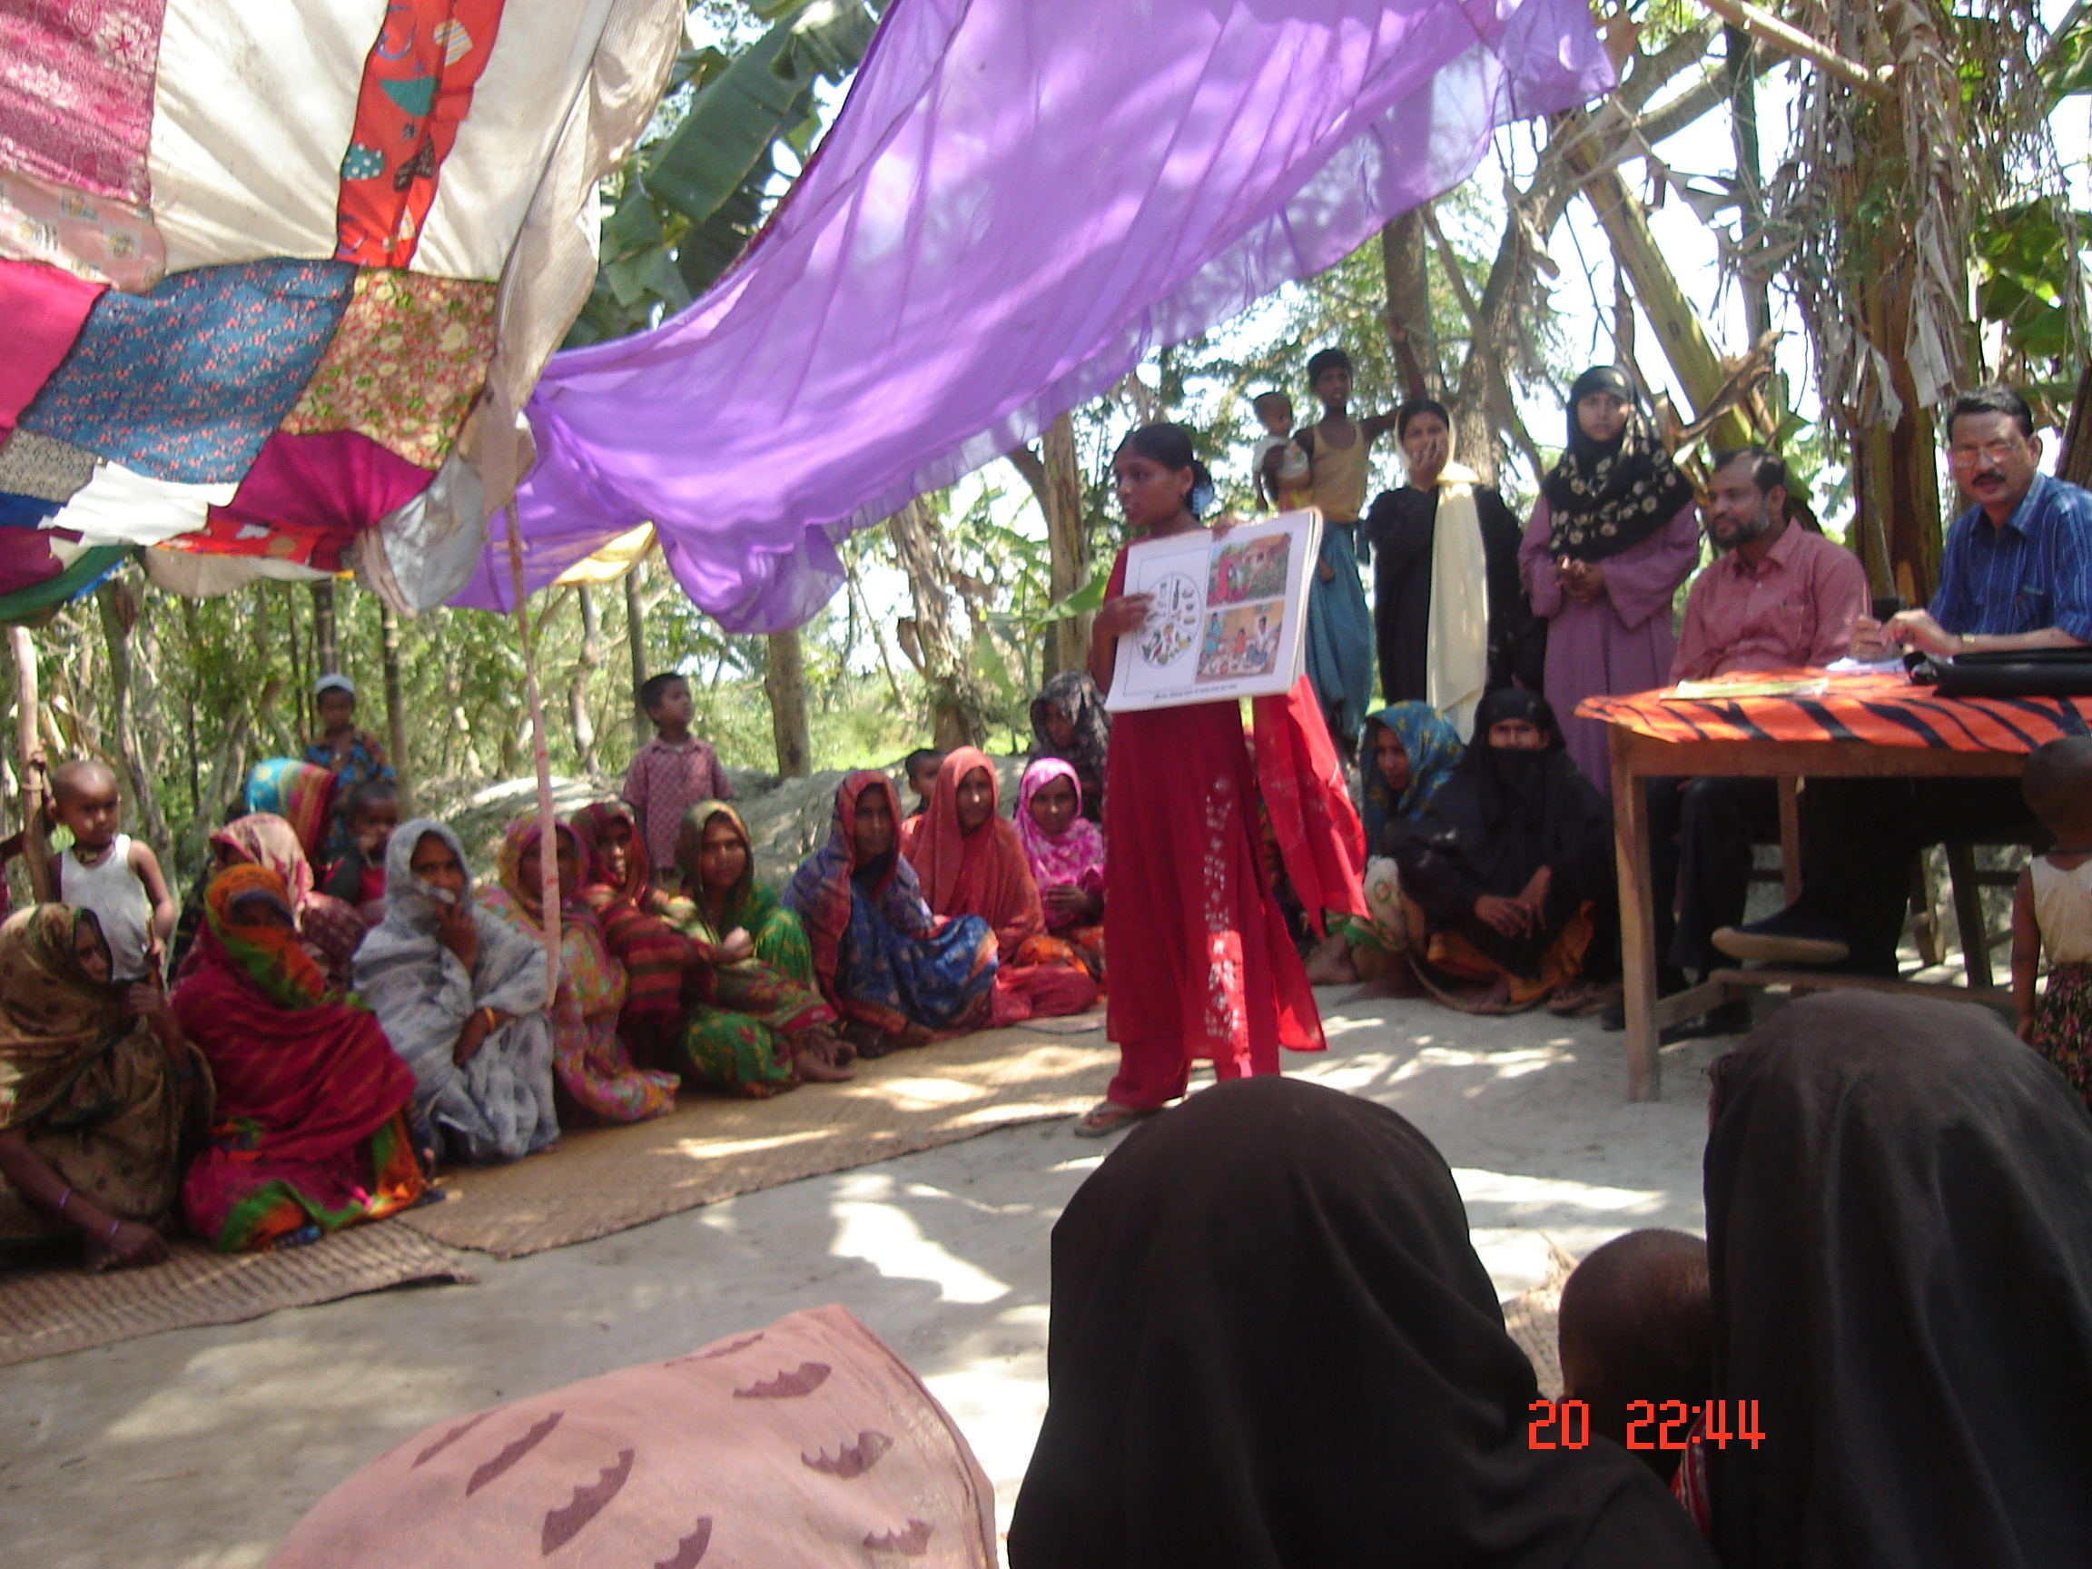
Each TBA is given responsibility to handle 120 households in her working area. She regularly visits to these households, keeps records on their health status, makes list of pregnant cases, handles delivery cases with care, refers complicated cases to the hospital.

Health forum~
Health forums are organized with assistance of the Shastha Shebika (SS) by the staffs of health and family planning program to disseminate health related knowledge and motivate all to practice family planning. These two-hour forums are arranged in the usual group meetings or elsewhere and the duration varies according to the importance of the issues discussed. Method used in these forums is participatory. A register is kept to record the decisions, list of participants, dates of follow up meetings, etc. Each health staff is required to arrange at least twenty health forums in a month and for that they are to prepare action plan listing probable dates and places of health forums. In the reporting period total 536 such forums were held where 9758 participants attended these forums.

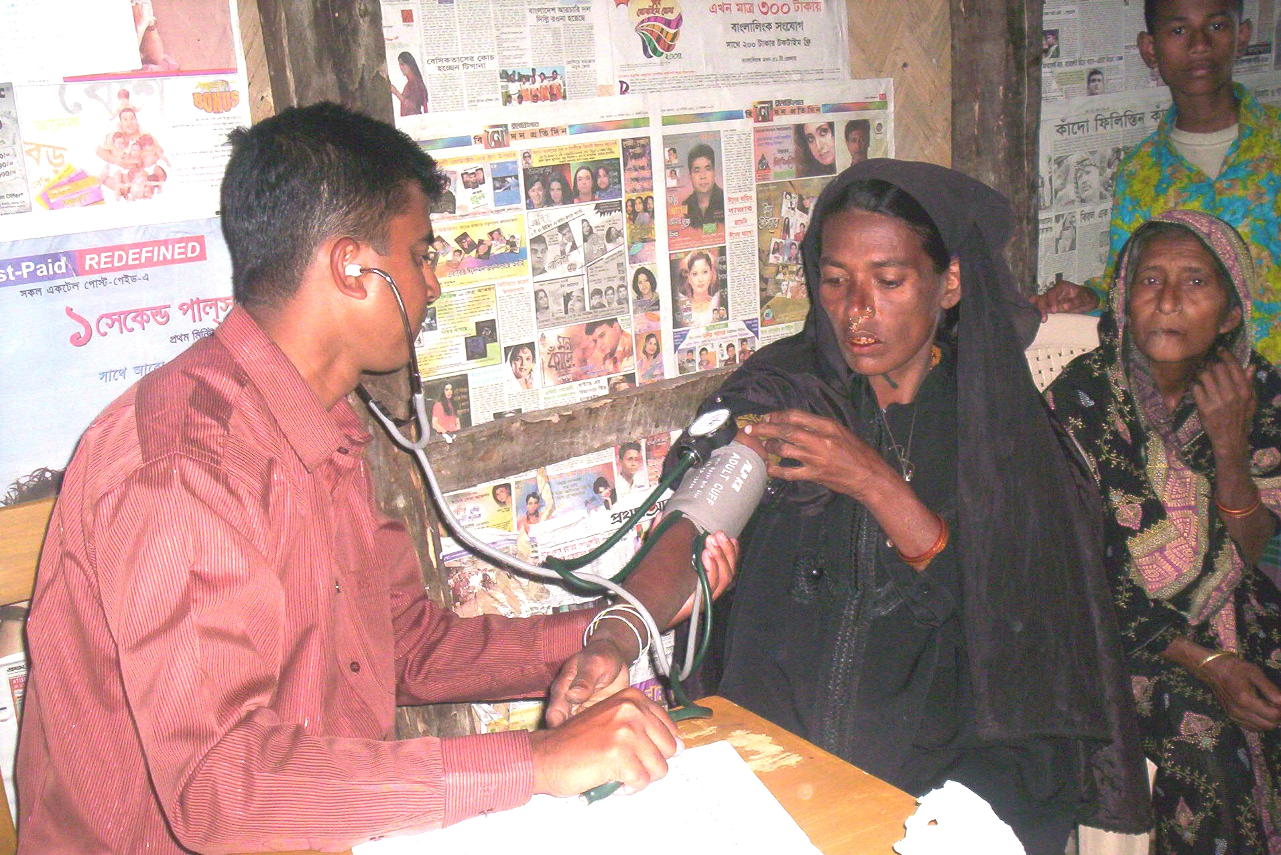
Clinic operation~
As mentioned already there is lack of professional doctors in the project area. General people having no other option falls prey of quack doctors. The health program has taken initiative to treat these helpless people by training medical assistants. The process of treatment basically divided into two ways.

These designated medical assistants provide treatment to people at the project offices on various diseases. This system is known as static clinic. Static clinics sit ten times per month on an average. Sometimes, SS selects treatment spots according to the need of local people at their convenient locations where medical assistant sits and treats patients there. This system is known as mobile clinic. In the reporting period 370 static clinics sat where 2669 patients received treatment. There were 199 mobile clinics where 3644 patients received treatment.

Family Planning~
HASI included family planning in the health component of the project assessing high rate of birth in the project area, a very usual scenario of rural Bangladesh. As our rural society is very conservative, a number of misunderstandings and misconceptions prevail relating to family planning.

This makes hard for the implementer of the program to materialize its objective. Despite such obstacles, our employees and other stakeholder are working very hard to motivate eligible couples to adopt family planning, specially the permanent method. .
A total of 660 were able to bring under family planning program in the last six months.

Delivery cases handled by TBAs~
Maternal health is very poor and child mortality rate is very high in the char areas compare to other parts of Bangladesh. The project therefore planned to trained traditional birth attendants (TBA) to provide better facilities to the pregnant women. These TBAs educate teenaged girls and women about maternal health and precautions to be taken during pregnancy. They also make aware of the neonatal and antenatal care to these women. The trained TBAs handle delivery cases and refer complicated issues to the hospitals.

Homestead Crop Cultivation

Staff Development~
There has a provision in the project to train up the staff and beneficiaries to develop their capacity and skill.One Group Facilitator (GF) is appointed to implement this program. He will deliver training to the farmer at the same time will supervise and monitor the program. One sector Specialist (Homestead Crop Cultivation) from BRAC will assist the GF (H. Crop) in respect to implement the program. Two staff was given six days residential training on vegetables cultivation at BRAC Comilla training center by a trainer in the reporting period August to June 2010. Our concept is that if one staff is dropped out from this program then another trained staff would be deployed in this program. The trained staff facilitates all types of training and refreshers of homestead crops cultivation program.

5: Farmers Forums:
In Boyer char the people are cultivating local variety of rice (Rajashail, Kajalshail). The yield of local variety is not satisfactory. So, in the project area the role of DAE (Department of Agriculture Extension) is to introduce HYV rice (such as BR-11, BR-14, BR-22, BR-23, BR-30, BR-31, BR-32, BR-40), Soybean, Mug bean, Sweet potato, Watermelon, Groundnut and Chili. The farmers are to be organized to provide support from DAE. DAE will transfer the modern technology of crop production through this organized group to increase the yield.
HASI-BRAC-CDSP-III will organize 08 Farmers Forum Group among eager farmers in Boyer char. In each group there would be thirty members (75% male and 25% female). DAE will provide technical support, training through this group. DAE will make demonstration plot to motivate the farmers. CDSP-III will assist DAE in every side to implement this program.

Formation of Farmers Forum~
During reporting PeriodHASI-BRAC- CDSP-III formed 08 farmers Forum .Total 240 members were enrolled to the forums to introduce HYV rice, mug bean, soybean, sweet potato, chili etc.In the reporting period August to June 2010 HASI-BRAC- CDSP-III distributed seed) among the selected farmers of the farmer’s forum.

Social Forestry
Introduction~
Bangladeshi’s forests are disappearing rapidly. At present only 9% of the country’s land area is forest whereas 25% forests of country’s land area is required for ecological balance. Deforestation is fucled by the high demand for timber (304 million cubic per year) in the country and fuel wood consumption (50 million cubic feet per year. The year demand will outstrip supply by 145.3 million cubic feet for timber and 28.2 million cubic feet for fuel wood. This rapid deforestation results environmental problems, including social erosion, land degradation, atmospheric pollution and even desertification. Due to removal of deforestation huge plantation is required in every year on marginal land, roadside, embankment, homestead, char land etc. Coastal char is the most vulnerable ecosystem characterized by tidal flooding, salinization, and threat of cyclone, storm surges, and socio- economic imbalance. The char dwellers live on their life with the adaptation of the environment. 80% people are living their life against the natural calamities. Every women and children do not get proper nutrition. Once the forest department developed mangrove forest in the char area as they were legally entitled to do so. After 20 to 25 years the people from different part of the coastal area migrated to the char. The people cut the forest for housing and agricultural activities. There was no forest those were developed by the forest department. Till date there was little afforestation in the area.

Homestead Plantation
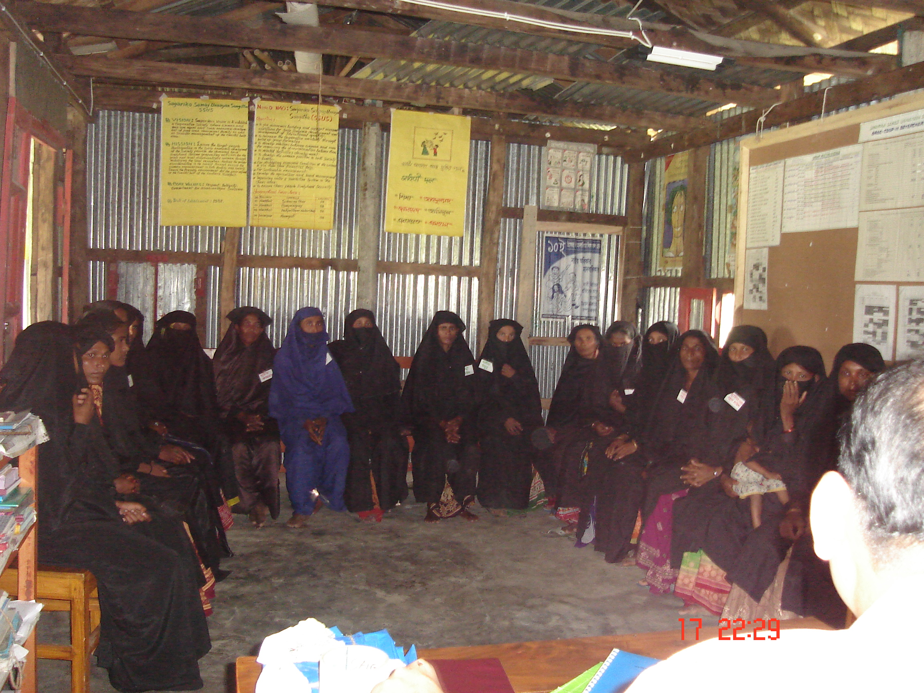
Homestead plantation training is crucially needed at Boyer char because timber, fruits & medicinal plants are inadequate to meet the demand for char dwellers. It is only 6%-7% (source from survey report) of homestead area under tree coverage. The availability of fruit is about 35 gm per head per day in the country, which is just half of the daily requirement. Fruits species have given the highest priority than other species for plantation because most of them cannot purchase fruit from the market due to financial insolvency. On the other hand the price of the fruit is higher than that of main land. For this reason they have been suffering from malnutrition. So HASI- BRAC –CDSP-III has given the best preferable of fruit species than other species.

Progress of Horticulture Nursery
After receiving revolving fund they purchased poly bag, seeds of 10 species, sprinkler, shade, bamboo, fencing and bearded other expenditure for their own cost. They sow the seeds to the seedbed/poly bag on seasonal time. They produced 220942 seedlings during the reporting period August- June 2010 and they expanded Tk 200000 for seedling production. Due to nursery establishment in the area it has been seen that new nursery is developing in the project area, Plantation is increasing day by day by trained women and women around them also. Now they prefer fruits species rather than timber & medicinal plant. Willingness to plantation is developing among the people. The beneficiaries are planting in a systematic way. People are planting in the homestead and out side homestead area. People are purchasing seedlings from the market, as the nursery owner cannot yet supply the seedlings to the locality. People are very happy to get the nursery in the project area so that they would be able to collect seedlings cheaply and easily in future. The nursery owner is working to their nursery with a hope to earn lot of money in near future. The husband of the nursery owner is helping them in nursery work, as they were reluctant to send their wife for training initially.

Poultry & Livestock program

Background of the Program~
In Bangladesh approximately 70% of landless rural women are directly or indirectly involved in poultry rearing activities. Together these small-scale producers contribute to the national poultry sector, which accounts for approximately 11% of the agricultural gross domestic product (GDP). HASI-BRAC-CDSP-III is committed to poverty reduction and empowerment of the poor through providing credit, training and technical assistance to its target group, charwomen. Those women often experience poor health at least in part due to poor diets and protein deficiencies. Poultry & Livestock Program in HASI- BRAC-CDSP-III aims to increase the income of char household and increase participants’ protein intake through the promotion of more efficient rearing practices and the supply of key inputs.

Present Situation of Poultry & Livestock activities~

The people in the char area were rearing poultry birds, cow, goat etc traditionally. They were not acquainted with modern rearing system. The service from the government of concern authority was quite absent. As the char area is far from the Sadar Upazilla. The livestock department could not provide and or is not providing any service to develop the poultry and livestock sector. There was no paravate to vaccinate or provide any suggestion to prevent the animal disease. As a result of mortality rate of poultry birds was much higher than that of the main land. The people could not provide Medicare facility for their family let alone poultry treatment due to poor economy. The people were not getting much benefit, as they should have from this sector. Whereas from such sectors people could be substantially benefited and can get involve with income by rearing poultry birds and meet the protein deficiency.

Staff Training: Qualitative staff needs technical knowledge and skill to implement the program. So HASI-BRAC-CDSP-III provides six days training course on poultry & Livestock rearing and management to the Group Facilitator (Poultry & Livestock). Training And Resources Center (TARC), BRAC conducted the training courses. A total of 5 number of staffs received the training Courses. If any staff dropout from poultry & Livestock program then another trained Staff will be deployed from rest twenty low.

Poultry Worker~
Training of beneficiaries~
HASI- BRAC-CDSP-III provided six days residential training course on poultry and livestock rearing and management in the training centre of SSUS, Boyer char. In the reporting period selected 10 Poultry workers received the training. Sector Specialist of Poultry & Livestock program conducted the training Course. Group Facilitator (Poultry & Livestock) of SSUS was as co- trainer.
Inputs distribute among Poultry Workers~
After completion of training course poultry worker got vaccine carrier, bag, bowl, syringe, medicine & vaccine s as a inputs.
Vaccination program: The major challenge faced in expanding small-scale poultry production is the high mortality rate of local birds. There is no vaccination program in Boyer Char. The Poultry & Livestock Program of HASI-BRAC-CDSP-III started the vaccination program in the Boyer Char from August 2006. It is a continuous process. The Staff will collect vaccines from Upazilla / District Livestock Office or local traders. The Poultry Worker collects the vaccine from concern office with the on cost and vaccinates the birds in the morning in a certain place that is selected on the day before by the birds Rearers. The Poultry Worker charged Tk.1.00 per bird to push injection and Tk. 0.50 per birds for eye drop. During the reporting period a total82595-dose vaccine used for vaccination program. 47980 doses are Ranikhet disease vaccine and a number of 37681 doses are Baby check Ranikhet disease vaccine.

Medicine Sale: The Poultry Worker sells poultry medicine in the locality according to the demand. After completion of training course Poultry Worker started medicine sale in the locality. They collect medicine from NGO office or local traders. In reporting period they sold Tk 13410. NGO wise performance are given below:

Refreshers Course: One-day refreshers courses are offering for the trained person to share experience and to recall the memory once in a month. In the refresher the Poultry Workers can provide the current and accurate information. The Group Facilitator conducts the refresher course with the help of Sector Specialist. In reporting period 163 participants were attended in refreshers course.

Key-Rearer: Selection~ In the reporting period 570 group members were selected for Key-rearer on the basis of selection criteria. The Group Facilitator of poultry & Livestock Program selected the key-rearer with the help of Group Facilitator (Group Formation & savings Management).

Water & Sanitation (WATSAN)

Capacity development: Skill is an essential tool to provide services to the people. HASI put the highest priority to the training of staff and beneficiaries to develop their capacity and skill so that they would be able to ensure the best services to the people they needed. HASI arranged various type of training and orientation to develop their capacity and skill where needed and will continue up the project period.

Staff training: The project aimed to develop the capacity of the WATSAN program. Two staffs got the training on WATSAN program. Only a staff will work in the WATSAN program. The other will be deployed if first one is dropped out.

Activities done in the reporting period~

Site selection for DTW: Water especially drinking water crisis is severe in the project area. Only 35 DTW are functioning in the area including newly installed DTW. People are to collect only for drinking purpose from long distant. Keeping the status in mind CDSP-III proposed 600 DTW to install in the area with soft ware assistance provided by HASI-BRAC-CDSP-III. HASI is selecting site of the DTW to install quickly to mitigate the problem which result health hazard in the area.

Selection process: They are selecting the site basis on some criteria which already given in the first progress report. Only a criterion was changed with the consultation of technical assistance team of CDSP-III. The changed criteria are the number of user group will be 14 to 18 instead of 10 to 15 earlier. Remaining all the criteria is unchanged. The staff of HASI and BRAC specialist goes to every house to see the feasibility of DTW site. Discussion with the local inhabitants also is made to accelerate the process. With the consent of the required number of user the primary selection is completed. At the time of selection the members must agree to contribute the money for DTW installation. Thus a primary list of DTW site is prepared and is preserved in the HASI project office. In the reporting period August’06 to June 2009 a total 127site of DTW has been selected.

Site selection for toilet : CDSP-III under took an attractive offer for the inhabitant of the people of Boyer Char. The happy news for them is every family will get a sanitary gradually. A total 11000 sanitary toilet will be distributed among the dwellers.

Selection process: The staffs of the HASI are moving to door to door to select the site of the toilet. The staffs are discussing with the household and in the group to make them aware about the site of the toilet. The staffs tell them where the site of the toilet would be feasible. What sort of place would suitable for the toilet. The beneficiaries are also aware about the use and maintenance of the toilet. They are also taught about the hygiene and proper use of toilet at the time of selection of site. No criteria have been following to select the site. The list of possible site is preserved in the HASI project office. In the reporting period August’08 to June 2011 a total 1414 site for toilet has been selected.

User Group Formation: To ensure the proper use and maintenance of the DTW formation of user group is essential. At the time of selecting the site the staffs make possible list of user group on basis of selected criteria. The member of the user group is 14 to 18. The total user will have the equal right to access to the water. Every user group member always will enjoy equal right in using the tube well. Two people from the group will get the training on tube well maintenance and care taking. The training will be two days duration and it will be held after the installation of DTW. Every user group will be provided a toolbox to repair the DTW and its maintenance. In addition the user group will receive education on health, sanitation, safe water from the staff and different training from the project. A total 127 deep tube well user group was formed in the reporting period August’06 to June 2011.

User group Meeting: The most important task of the user group is to take proper care and ensure the maintenance of the DTW. The staff of the sector always is conducting the meeting with the user group before and later of the installation of the DTW. In the meeting the staff discuss about the hygiene and proper use of DTW. In the meeting the use of the different tools of the DTW to repair and maintenance is also discussed. The programs aims to ensure the use of water in the entire house hold work. Follow up is also paid after meeting to see the arrangement of preservation of toolbox. A total 100-group meeting was conducted with the user group of the deep tube well in the reporting period August’06 to June 2011.

Contribution money collection: HASI-BRAC-CDSP-III project staff makes the people aware about the safe water, hygiene, use of DTW through meeting, and training and personal contract. Department of Public Health and Engineering (DPHE) install the DTW. CDSP-III technical team sees the feasibility of the site. Tk. 4500 is to pay as contribution for each DTW. BRAC-CDSP-III project staff motivates the people and form user group and collect contribution money from the user group. The site is selected according to their opinion. Each of group members is to contribute the same amount of money but in real it is not possible in all cases. In some extent it has been seen that the contribution money is not equal in amount. But the access to the DTW is equal almost everywhere.

Hygiene promotion:
One of the most important aims of the sector is to raise awareness among the people in the project area. Several tools are using to perform such task. The staff of the sector of HASI t are conducting courtyard meeting, tea stall session, meeting in the different educational institutions and individual contract are being made. `

Impact of the program~
The people in the project area were asking the HASI staff and BRAC-CDSP-III sectors specialist about the time of installation of DTW. They were asking and making request in every forum for quick installation of DTW as they are becoming aware about the advantage of safe water. People are ready to pay the contribution money to get the DTW on priority basis. All walks of people are using the water of DTW collecting even in a line. The people are also becoming aware about sanitary latrine. The beneficiaries are asking our staff to provide the latrines also as they know the economic and social benefit of a sanitary latrine. The shopkeepers especially in tea seller are using the water from DTW where water is available.

A brief overview of HASI- SHOUHARDO Program

Major Activities

Major activities of the projects and highlights the key achievements during the reporting period.

Village Development Committee (VDC)

A VDC is formed with 11-17 members managing committee. The task of VDC is to identify the khash land and government resources. They will work for good governance keeping close relation with the member of local government unit. The member of the VDC will try to make the people aware to eradicate all type of irregularities from the society. A committee is formed in each VDC group is known as managing committee. The committee will meet with the member of the VDC once in two month. They will discuss about the present problems prevailing in the society and the progress of the activities they have to done within the framework. During Reporting Period total number VDC Meeting held 417.

Occupational Group
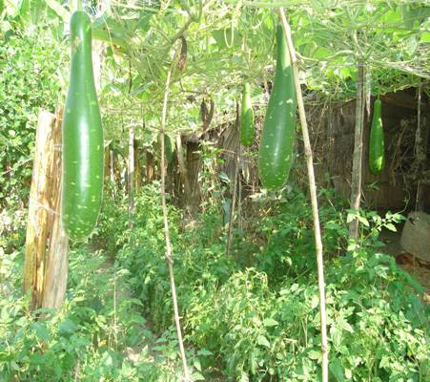
The Participant of the program consist of 4 major occupational groups : Agriculture based, fisheries, comprehensive homestead development (CHD) based and income generation activities based.
Agriculture based group : HASI provided skill training to agriculture farmers to improve there knowledge and transfer modern techniques and technologies during reporting period total number of 2176 participants received training and they engaged in agriculture practices.
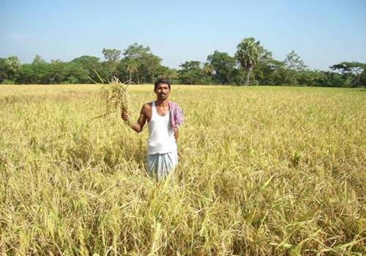
2.2 Fisheries based group : HASI provided training to the fisheries Participant to improve there knowledge, skill and transfer modern techniques and technologies during reporting period total number of 1316 participants received training and they engaged in agriculture practices.
2.3 CHD based group : HASI provided training to the CHD Participant to improve there knowledge, skill and transfer modern techniques and technologies during reporting period total number of 1068 participants received training and they engaged in CHD practices.

IGA based group : HASI provided training to the IGA Participant to improve there knowledge, skill and transfer modern techniques and technologies during reporting period total number of 1024 participants received training and they engaged in IGA practices.

MCHN : A Significant dimension to SHOUHARDO Program is providing direct food assistance to beneficiaries to mitigate under nutrition of children from the on set to positively impact on “stunting” and “wasting”. Food is therefore distributed under the MCHN (Mother, Child, Health and Nutrition) component to Pregnant and lactating mothers to ensure that they remain healthy, via which the children they nurse are also kapt healthy within the first two years of theirs lives. During reporting period MCHN Ration distributed to pregnant 1588 and lactating 2704 beneficiaries.

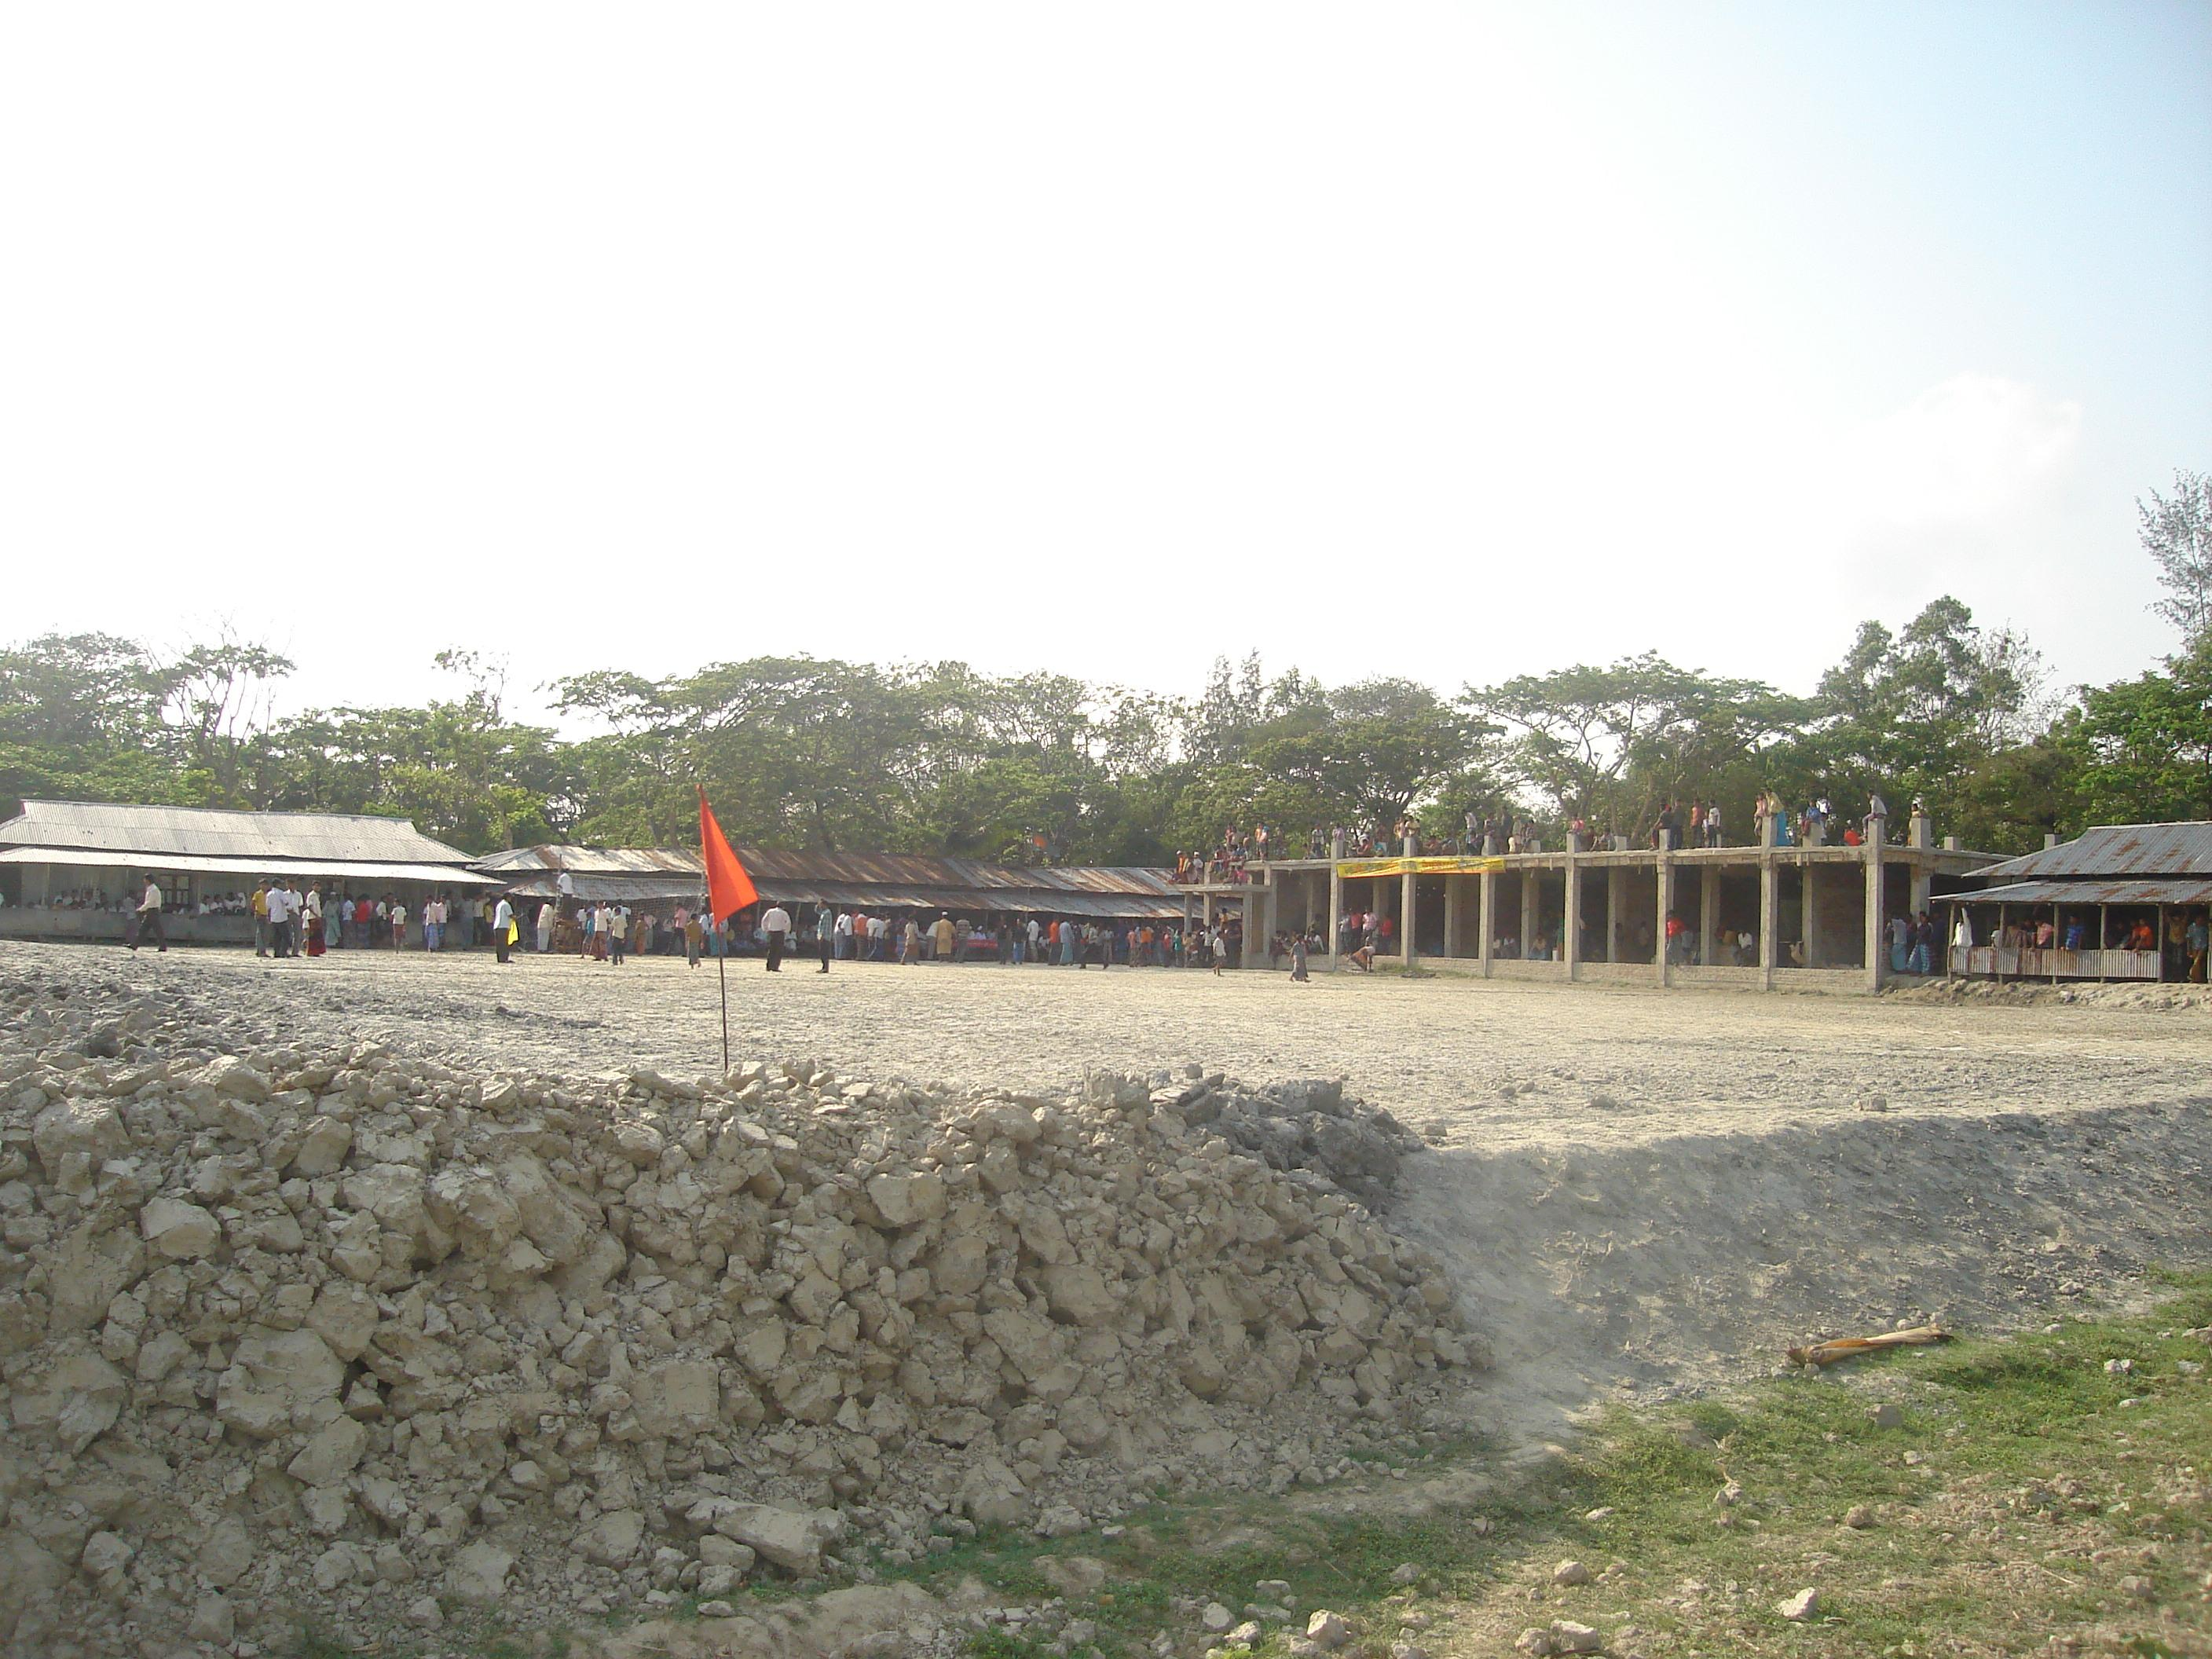
Infrastructure and CFW/FFW: Infrastructure and CFW/FFW component is the impotent element of the program. SHOUHARDO Program generates employment opportunities for the hardest hit population within the target population thereby elaborating potential under nutrition in this period.

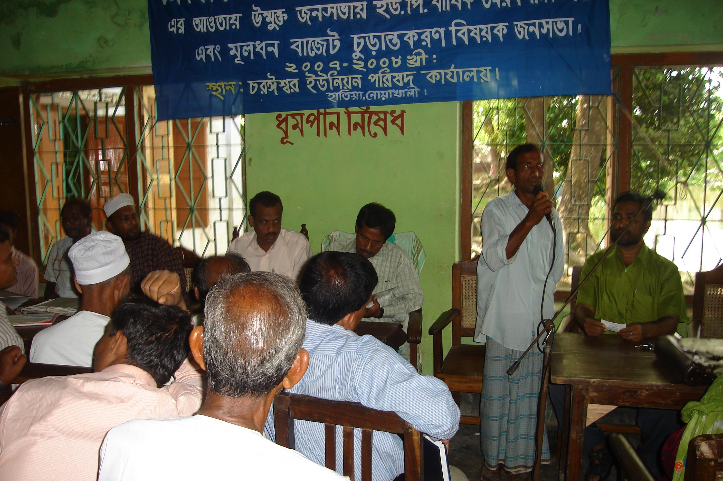
Governance:
SHOUHARDO provided training to the LEB’s and service providers to improved their professionalism and accountability to the service recipient. HASI arranged deferent types of workshop and discussion session to activate and reactivate deferent standing committee.

Advocacy:
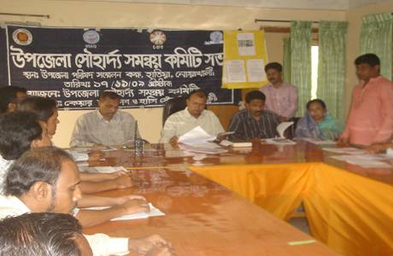
HASI facilitates numerous advocacy and awareness campaign as activities to increase knowledge, promote, behavioral change, influence policy, implement program and increase under standing of the issues of the hardcore poor.

Disable of the program

The disabled people are mostly deprived of all respects in the society. The society thinks, they are curse of sin. So, people neglect them and try to avoid them, There is lot of disabled people in the areas and they are passing miserable and painful lives in the society. HASI has been trying to make the people aware that they are not the result of sin. So, they should not be neglected and avoided. Every one should take pity on the disabled people. It has been providing different services, like treatment services, physical exercises services, provide aid materials, education, and training and also provides credit support income generating activities. HASI has got training support from Center for Disability in Development (CDD) Savar to serve the disabled people. Four members of staff got well training on the disabled people from CDD. HASI has already identified 320 Disabled people in Hatiya upzilla and giving therapy to 60 Disabled children. Out of the total number several children are sent to school and some brought under the income generating activities.
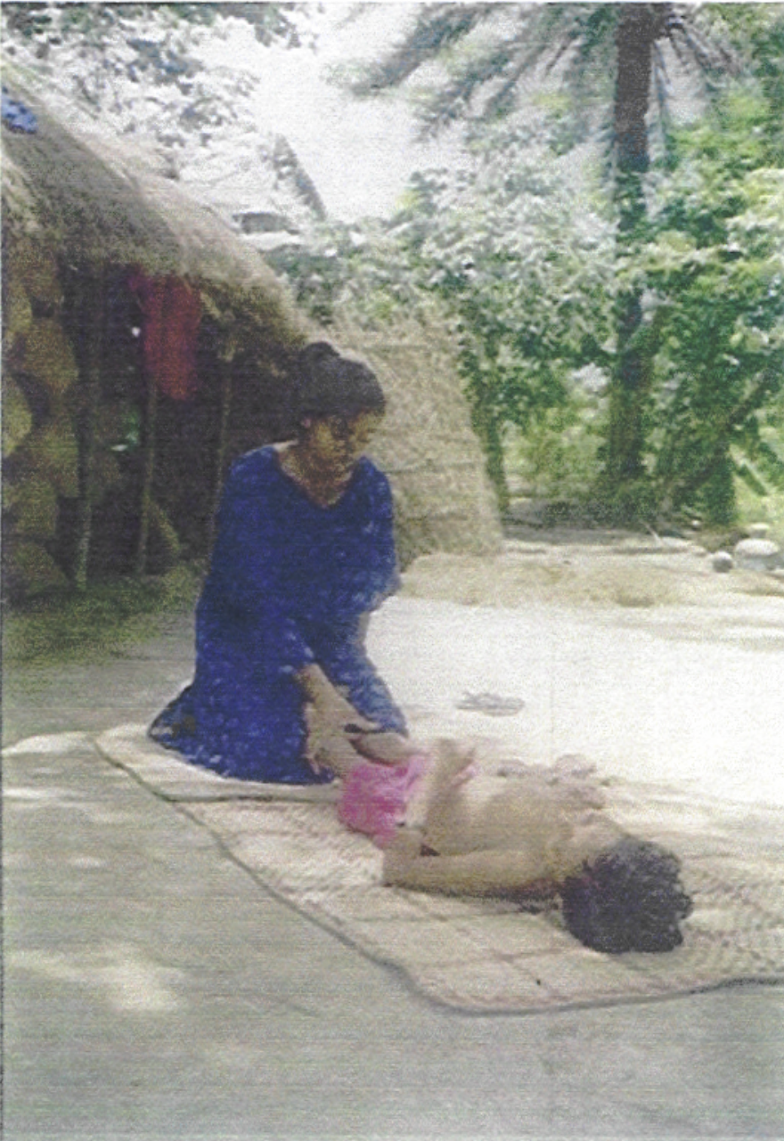

Therapy to Disabled Children
Non-Formal Primary Education (NFPE)
The Non-Formal Primary Education Commonly known as NFPE was first imitated in 2003 when HASI decided to protect drop out children/ unserved children of Hatiya and adjacent char dwellers with the financial & technical support of BRAC. Through Education Support Program (ESP), BRAC given ten schools to HASI in the reporting period. A total of 300 students were enrolled in that school. A total of 220 are female students and the rest of Male students.
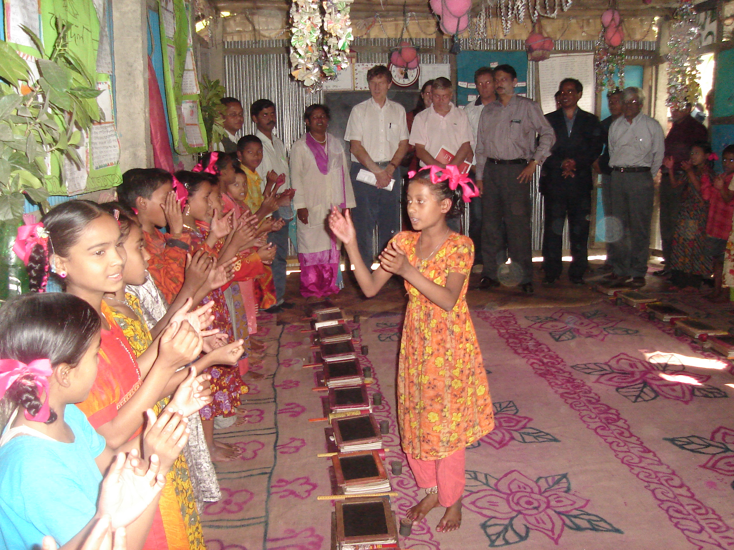 | 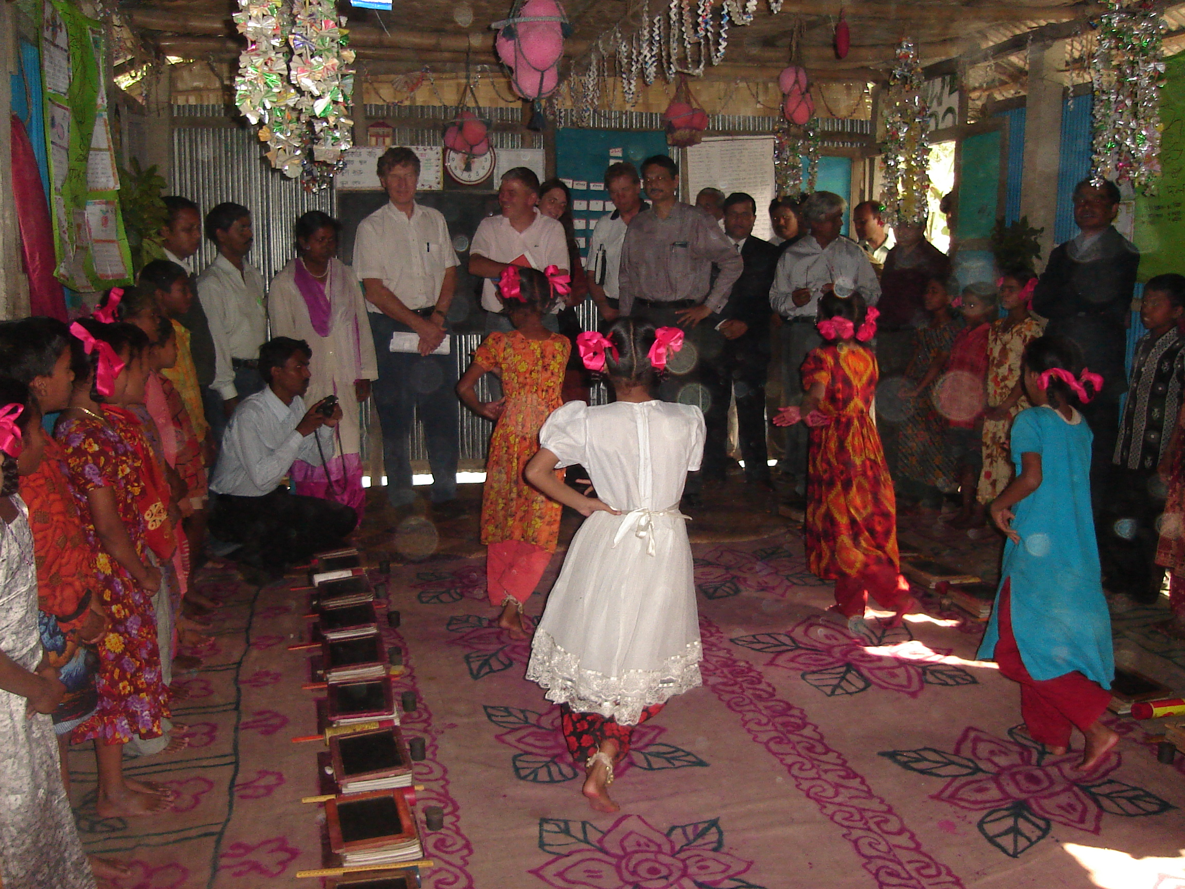
Honorable Ambassador of Netherlands Visited HASI School.
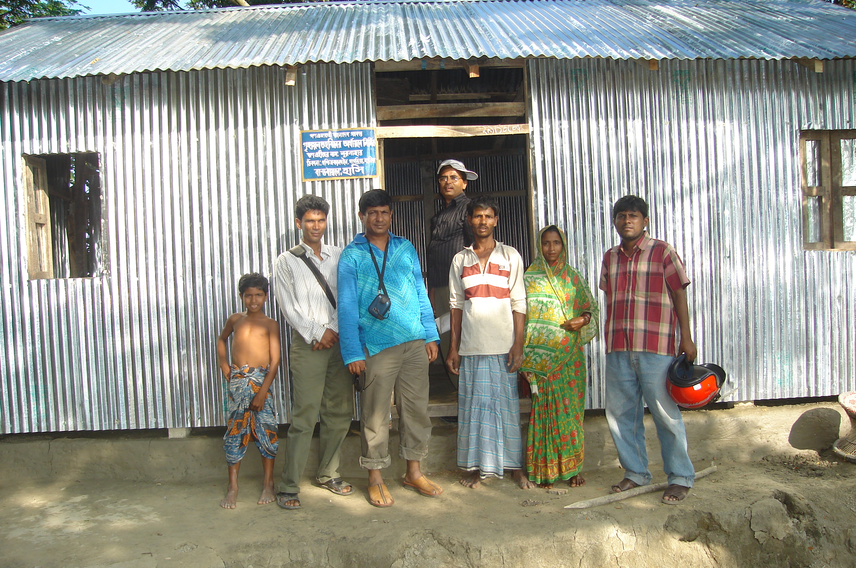
Rural Housing Program For Disadvantaged people:
Most of the people of Hatiya are living in the Very adverse situation of housing because of river erosion. Hatiya is most disaster prone area of Bangladesh. In this respect HASI thought about the situation of housing of poor people, HASI started rural housing program. During reporting period total number of house handover to the beneficiaries 38.
Micro-Finance Program for Poverty Reduction.
Group Formation & Savings Management:

Lack of access to formal financial institutions makes it difficult for the poor to get involve in the productive activities in the remote areas. HASI wants to bring a change in this prevailing situation and has opted for microfinance to give credit facilities to these disadvantaged groups in the society. In order to bring the rural poor into the mainstream of development, HASI focuses on institution building in its micro finance program with the financial support of BRAC-NCU and provides necessary guidance and capacity development required to make the VO a common platform for all the poor char dwellers as a strategy of inclusion. Under the program group formation acts as laying foundation of all development activities and also develops savings culture among the members of these groups. These groups are known as Village Organizations (VO). In Boyerchar The program offers credit to its VO members to initiate different income generating activities. An important component of the credit operation is in the collection of savings and HASI’s experience has shown that the regular savings contribution yields better discipline in the VO credit operation. From the member’s point of view, savings represent an opportunity to save a lump sum and earn interest of which they could not have benefited from the formal market or regular financial institutions. Savings opportunities provide members with funds for consumption, children education and other investments. It also provides security for old age and serves as a contingency fund during natural disasters in case income level fluctuations.
A total of 94 groups were formed in the reporting period. The following table shows the number of groups formed thus far.

Staff training:
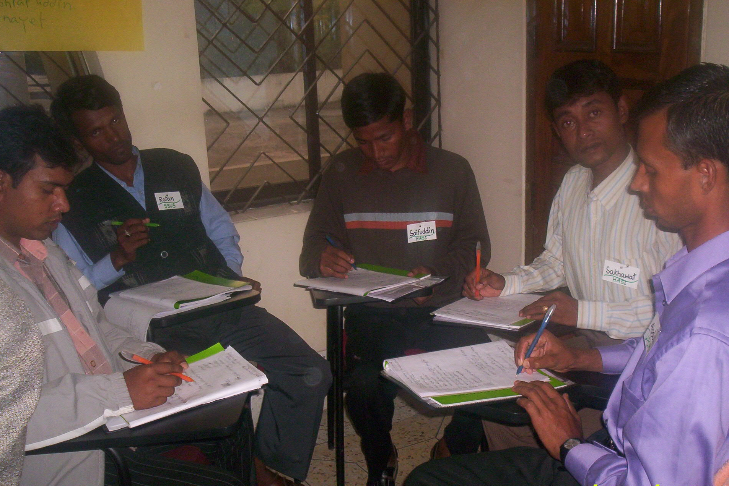
The project intends to enhance capacity building of the staffs involved in the implementation of group formation and monitoring of the credit operation. During the reporting period, twelve staffs have been received training on group formation & savings management and micro credit management. The training was being held at the Comilla TARC.
Beneficiaries training: HASI has been signed a MOU with the BRAC to provide all training of the project. In this reference BRAC training division has designed intensive training programs for the beneficiaries of the groups. HASI has formed groups and all the activities of the project are centered on these groups. There is a managing committee in each group. Chairman, cashier, secretary are the members in the managing committee of a group. In addition there are small groups consisting five members in each group. Every small group has a leader. The leader manages the small group activities and the managing committee guides the whole group. The committee is responsible for all the disciplinary actions of the group. The project aims to train all the leaders to develop their capacity to guide the groups and maintain good governance among the groups. The theme is to train them to make the group sustainable so that these groups can continue working independently even after the project ends. The duration of the training was three days.

The trained staff of HASI conducted the training with the help of BRAC sector specialist. In the reporting period, a total 396 beneficiaries got training on group formation and savings management.
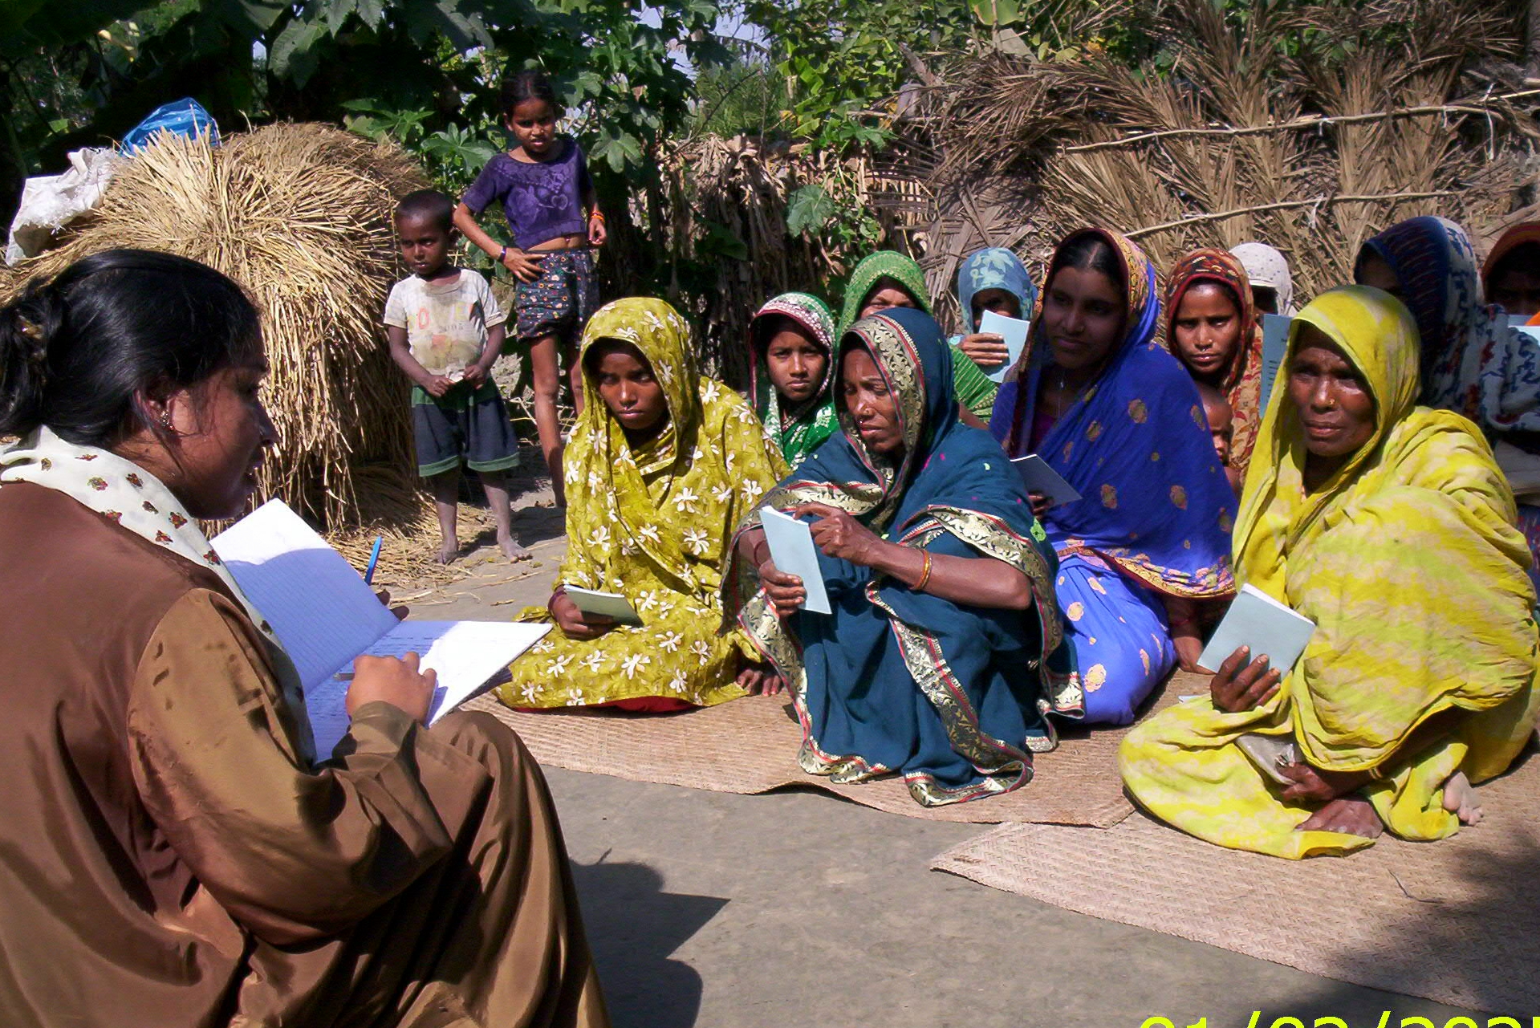
Area demarcation for group formation~
Area demarcation is a pre requisite for group formation. The geographical area of a group is settled at the time of area demarcation. It is required to fix and select the group members and the executive committee members in a specific area. Area segregation in fact helps fostering the sense of responsibility among the group members making positive impact on the monitoring performance of credit operation and other group activities. Sixty areas are demarcated for group formation in the reporting period and are functioning presently.

Group meeting~
To keep close relationship with the group members and to impart knowledge among them, a group sits several times in a month. As these meetings play quite important role in bringing the members close to each other and also with implementing agency member, the group meeting is fixed once in a week. The group facilitator usually discusses about savings, credit, and other issues in these meetings before collecting weekly savings dues. The project staffs responsible for sectoral activities also share important issues in the meeting if need be. A total of 10200 group meetings were conducted in the reporting period.

Savings collection

Each member of a group is to deposit a certain small amount per week to the representative of the implementation agencies who in turn keep it in the bank account in the name of the member. A member can withdraw her/his savings partially at the time of need. These savings generate interest calculated at the end of every financial year as per bank rate. A total of Tk.35,20,672/- savings was collected in the reporting period. The table below shows total savings collected in the reporting period

Loan disbursement:

There has not been kept a provision of credit facilities under this project. But, past working experience of HASI various categories of poor reveals that after they are organized and adequate training is departed, the demand for credit arises as they feel encouraged and gain enough confidence to engage them in the small income generating activities. Analyzing a demand for credit, HASI started their credit scheme from their own fund and some other donors’ fund. In the reporting period a total Tk-1,36,15,000/- was disbursed as loan in the reporting period.

The project has been able to make several positive impacts on the lifestyle of the char dwellers, specially, the women. Women were not shown much respect and their hard labor in the household used to go unnoticed and unrecognized. Group formation has laid a foundation of forming an organized structural infrastructure for the poor communities to develop and grown to be a part of the developed society.

Groups began to make people aware of the most important issues of human lives and disseminate vital information on basic health care and cleanliness, education, income generating activities, capacity building, etc.

Group formation unlocks an opportunity for poor to meet on a regular basis, share their views and ideas and also share experiences of life. This spawns a social bonding among the group members who come from the same social strata and thus help resolve issues of importance in their lives together in a more effective manner.

These group members are entailed to practice savings habits, which invariably prove to be beneficial to the group members in the long run. Savings habit in turn alleviates the group members-most of those are women- to be more economic and disciplined in life. This has helped them a lot securing respect in the male dominated societies in the rural Bangladesh as the women folk started to contribute in the family expenses by getting them involved in various income generating activities. This has enhanced their status in the society and they started to play active role in decision-making process in the family as well as in the society. Women have begun to realize that economic power is the indicator of social status. Economic independence is the pre-condition of social liberty.

Donors:

Since inception, HASI has been implementing different kinds of development activities with the help of local contribution and donors donations. At present it is getting supports for the following donors:

Project Name | Donors Name
HASI-BRAC-CDSP-III | Netherlands embassy and BRAC
SHOUHARDO Program | GOB, USAID and CARE Bangladesh
Disable Development Program | HASI & Bangladesh NGO Foundation
Non-Formal Primary Education | BRAC-ESP
Rural Housing Program For  Disadvantaged people | Bangladesh Bank
Micro-Finance Program For  Poverty Reduction | BRAC-NCU and CODEC , MAC Foundation
Aila Rehab Project | GOB, USAID and CARE Bangladesh
kishory saglap | Stromme Foundation (Norway)& CODEC
HYSAWA Program | Ministry of LGRD & C & DANIDA, SDC
VGD Program | GOB(Ministry of Women & Children Affairs), WFP
Training Centre of HASI

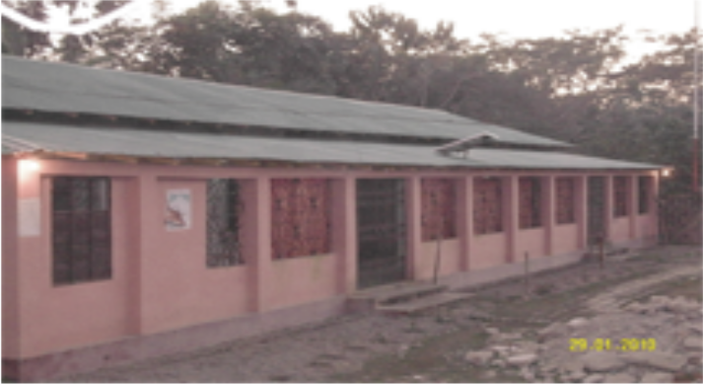
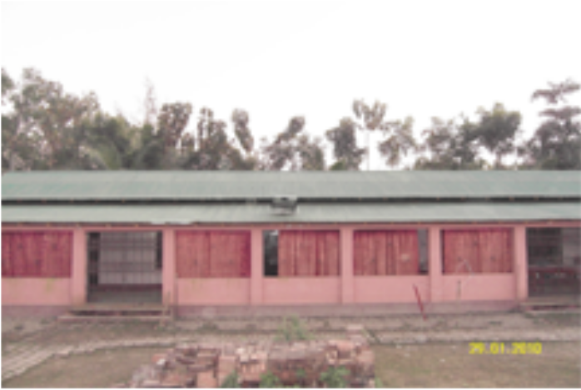

List of assets properties of the organization
Sl. | Name of Equipment | Quantity | Year of Procurement | Status
01 | Steel Almira | 6 | 1996-2017 | Good Condition
02. | Computer | 3 set | 1998-2015 | Good Condition
03 | Motor Cycle | 14 | 2000-2012 | Good Condition
04 | Bi-cycle | 25 | 1996-2013 | Good Condition
05 | File Cabinet | 22 | 1996-2015 | Good Condition
06 | Chair with arm | 22 No. | 1996-2013 | Good Condition
07 | Chair without arm | 60 | 1996-2017 | Good Condition
08 | Secretariat Table | 15 | 1996-2017 | Good Condition
09 | Long Table | 7 | 1996-2017 | Good Condition
10 | Harmonium | 1 set | 1999-2008 | Workable
11 | Musical Drum | 1 set | 1999-2008 | Workable
12 | Bookshelf | 3 no | 2000-2012 | Workable
13 | Ceiling Fan | 12 | 1996-2017 | Good Condition
14 | Table Fan | 4 | 1996-2017 | Good Condition
15 | Projector & Screen | 1 | 2016 | Good Condition
16 | Camera | 1 | 1996-2013 | Good Condition
17 | Handy Video Camera | 1 | 1998-2010 | Good Condition
 | Training Center | 1 | 2006 | Good Condition
Conclusion:

HASI has done a good work in the field of rural development in its operation areas, with the active and sincere co-operation of the Executive Committee members, staff, local people, Government departments and donors, though there were lot of limitations, barriers and problems. Problems will exist, if some works are done, but those problems will have to be solved through our sincere efforts and dedication. HASI is developing its staff members and volunteers through practical experiences, and skills to undertake more challenging activities in future. We had lot of mistakes and lacking but we are trying to cover all sorts of lacking and mistakes for future implementation. If HASI gets all sorts of co-operation from different corners it could be able to contribute for rural development in its operation areas. So, it anticipates co-operation, and assistance from all corners to implement its development activities.

